*Lecture Experiments of “Embedded Programming”:-
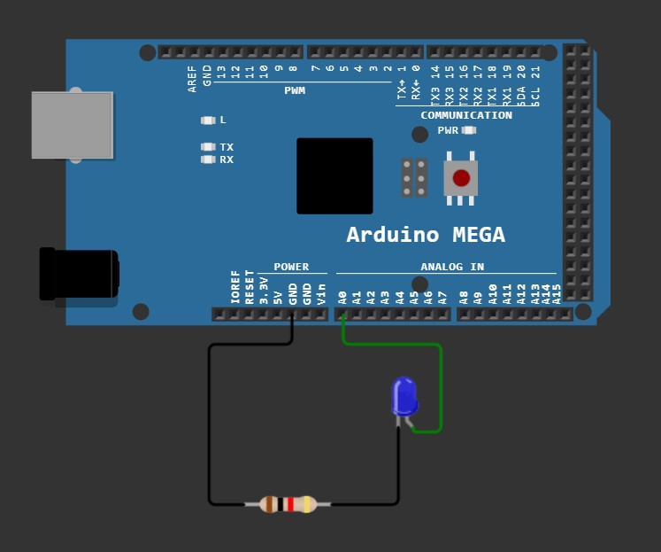
01. Led Blinking:-

void setup() {

volatile char *dirf = 0x30; *dirf=0xff;
volatile char *outf = 0x31;
volatile long i;

while(1)
{
*outf=0x01;
for(i=0; i<100000; i++);
*outf=0x00;
for(i=0; i<100000; i++);
}

}

void loop() {}

02. Led Scrooling:-

#include "dk.h"

void setup() {
initf(0xff);
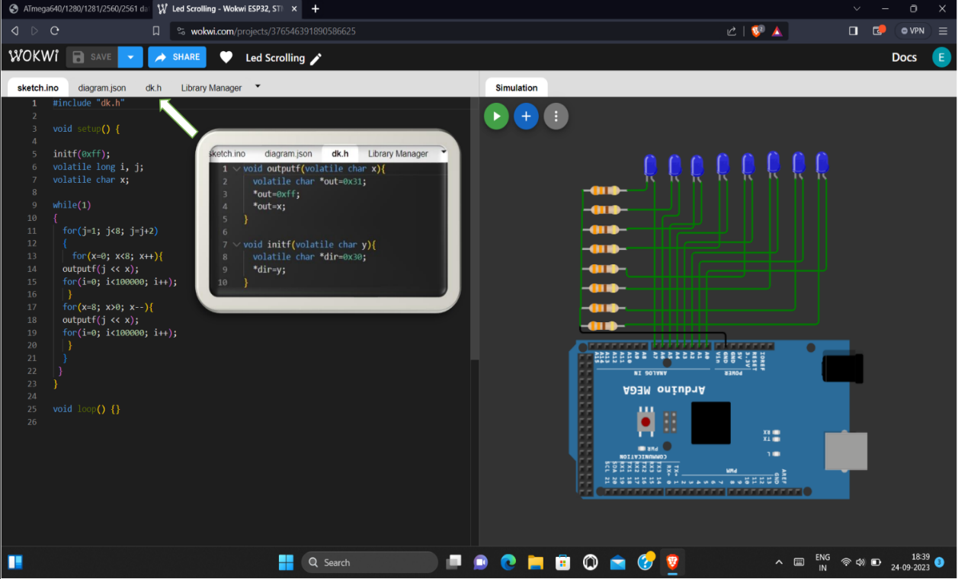
volatile long i, j;
volatile char x;

while(1)
{
for(j=1; j<8; j=j+2)
{
for(x=0; x<8; x++){
outputf(j << x);
for(i=0; i<100000; i++);
}
for(x=8; x>0; x--){
outputf(j << x);
for(i=0; i<100000; i++);
}
}
}
}
void loop() {}

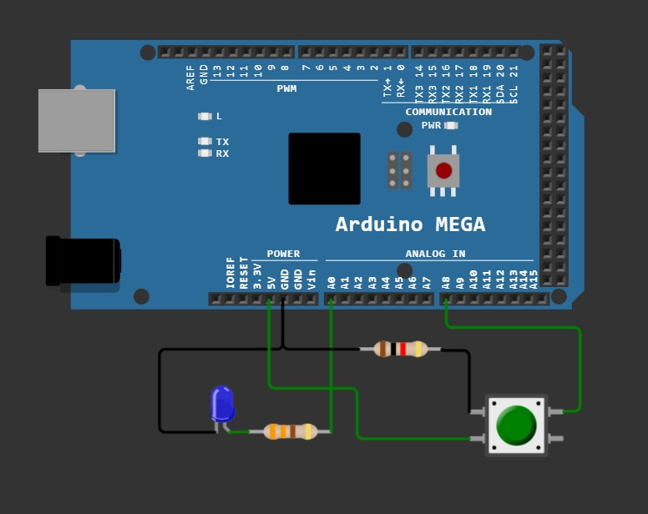
03. Led & Switch:-

void setup() {
volatile char *dirf, *dirk, *outf, *ink;
dirf=0x30; *dirf=0x01; // port f set as output
dirk=0x107; *dirk=0x00; // port k set as input
outf=0x31;
ink=0x106;
volatile char x;

while(1){
x=*ink;
if((x & 1)==1) *outf=1;
else *outf=0;
}
}

void loop() {}

04.Two Leds & Switch:-

void setup() {
volatile char *dirf, *dirk, *outf, *ink;
dirf=0x30; *dirf=0x03; // pin 1 & 2 of port f set as output
dirk=0x107; *dirk=0x00; // port k set as input
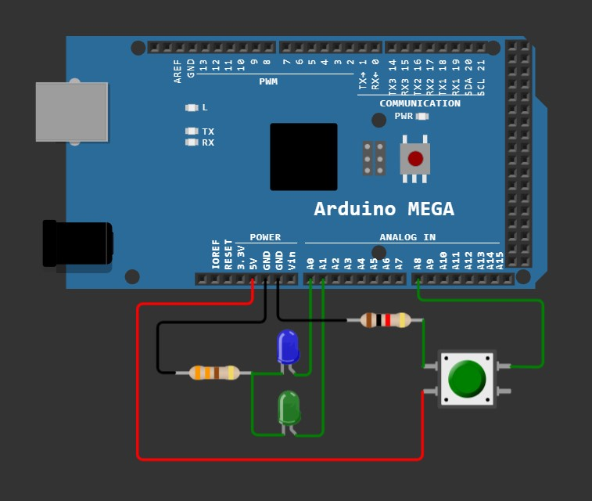
outf=0x31;
ink=0x106;
volatile char x, i=0;
volatile long j;

while(1){
x=*ink;
if((x & 1)==1) i++;
for(j=0; j<50000; j++);

if(i%2) *outf=1;
else *outf=2;
}
}

void loop() {}

05. Seven Segment:-

void setup() {
volatile char *dirf, *outf;
volatile char a[]={0x3f,0x06,0x5b,0x4f,0x66,0x6d,0x7d,0x07,0x7f, 0x6f};
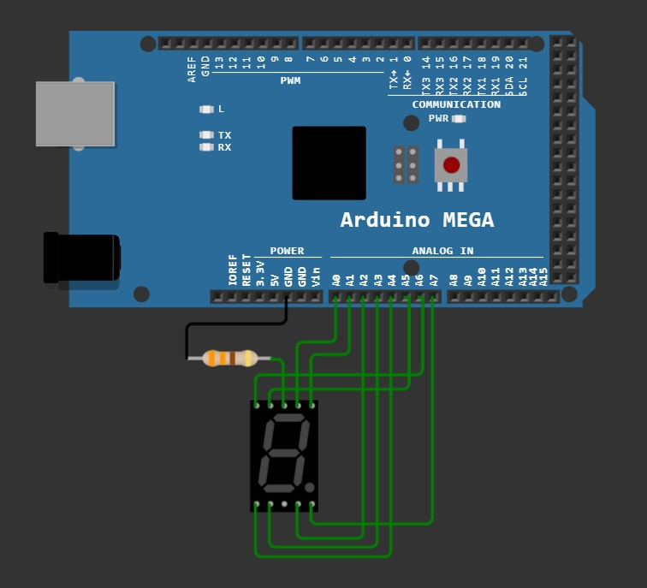
dirf=0x30;
*dirf=0xff;
outf=0x31;
volatile long i, j;

while(1) {
for(i=0; i<10; i++)
{
*outf=a[i];
for(j=0; j<500000; j++);
}
}
}

void loop() {}

06. Keypad:-

void setup() {
volatile char *dirf, *outf, *dirk, *ink, *dira, *outa, *dirc, *outc;
volatile long i, j;

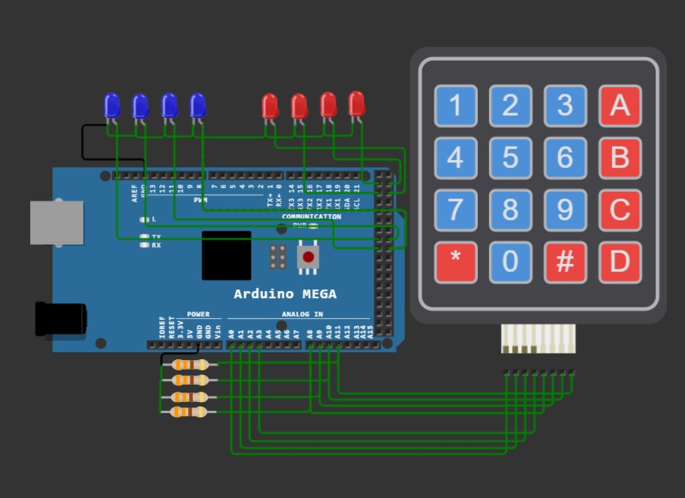
dirf=0x30; *dirf=0xff; outf=0x31;
dirk=0x107; *dirk=0x00; ink=0x106;
dira=0x21; *dira=0xff; outa=0x22;
dirc=0x27; *dirc=0xff; outc=0x28;

while(1){
for(i=0; i<4; i++)
{
*outf = 1 << i;
*outa = *ink;
if(*ink != 0){
*outc = 1 << i;
for(j=0; j<500000; j++);
*outc = 0;
}
}
}
}
void loop() {}

07. 8*8 Dot Matrix:-
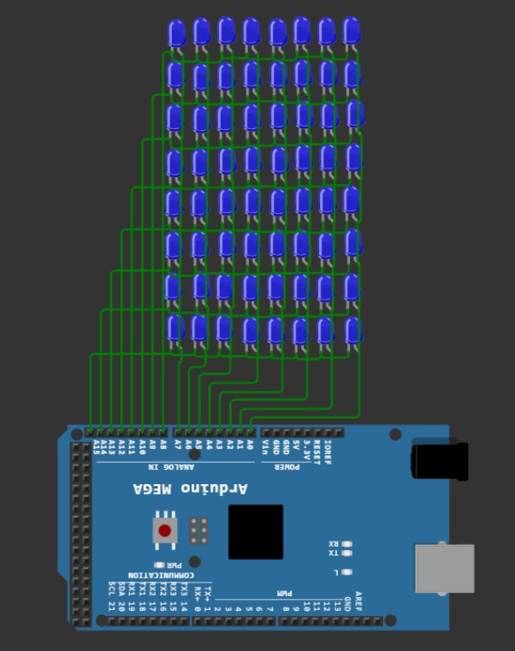
void setup() {

volatile char *dirf, *dirk, *outf, *outk;
volatile long k;
char row, col;
dirf=0x30; *dirf=0xff;
dirk=0x107; *dirk=0xff;
outf=0x31; outk=0x108;
while(1)
{
for(row=0; row<8; row++){
*outk= ~ (1 << row);
for(col=0; col<8; col++){
*outf= 1 << col;
for(k=0; k<100000; k++);
}
*outk= 0xff;
*outf= 0;
}
}
}
void loop() {}

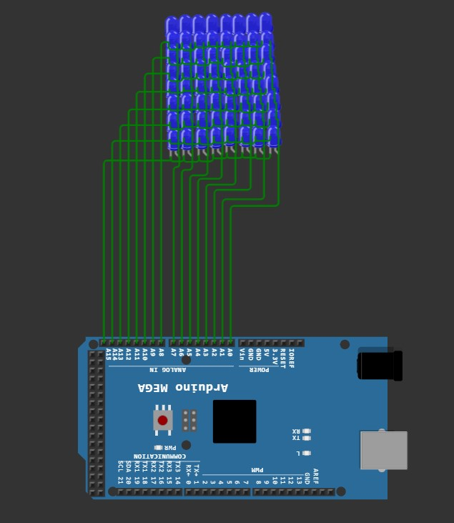
08. 8*8 Dot Matrix Display [ECEN]:-

void setup() {

volatile char *dirf, *dirk, *outf, *outk;
volatile long a;
char i, count=0;

dirf=0x30; *dirf=0xff;
dirk=0x107; *dirk=0xff;
outf=0x31; outk=0x108;

volatile char ecen[][8] = {
{0b11111111,
0b11111111,
0b11000000,
0b11111111,
0b11111111,
0b11000000,
0b11111111,
0b11111111},

{0b00111110,
0b01111111,
0b11100011,
0b11000000,
0b11000000,
0b11100011,
0b01111111,
0b00111110},

{0b11111111,
0b11111111,
0b11000000,
0b11111111,
0b11111111,
0b11000000,
0b11111111,
0b11111111},

{0b11000011,
0b11100011,
0b11110011,
0b11111011,
0b11011111,
0b11001111,
0b11000111,
0b11000011}};

while(1){
for(a=0; a<20000; a++){
for(i=0; i<8; i++)
{
*outk= ~(1 << i);
*outf = ecen[count][i];
*outk=0xff;
*outf=0;
}
}

for(a=0; a<45000; a++);
count++;
if(count==4) count=0;

}
}
void loop() {}

* Embedded Programming Problem Sets:-
1. Glow LSB LED only (bit 0):-  void setup() {  volatile char *dirf, *outf;  dirf=0x30; *dirf=0xff;  outf=0x31;  *outf=1;  }  void loop() {} | 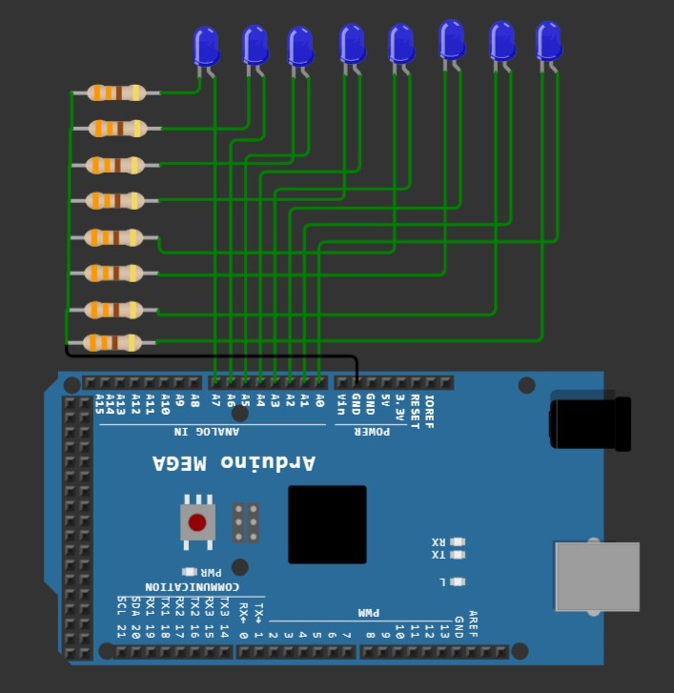
2. Glow MSB LED only (bit 7):-  void setup() {  volatile char *dirf, *outf;  dirf=0x30; *dirf=0xff;  outf=0x31;  *outf=0x80;  }  void loop() {} | 3. Glow LSB 2 LEDs only (bit 0 & bit 1):-  void setup() {  volatile char *dirf, *outf;  dirf=0x30; *dirf=0xff;  outf=0x31;  *outf=3;  }  void loop() {}
4. Glow MSB 2 LEDs only (bit 7 & bit 6):-  void setup() {  volatile char *dirf, *outf;  dirf=0x30; *dirf=0xff;  outf=0x31;  *outf=0xc0;  }  void loop() {} | 5. Glow LSB 4 LEDs only (bit 0 to bit 3):-  void setup() {  volatile char *dirf, *outf;  dirf=0x30; *dirf=0xff;  outf=0x31;  *outf=0x0f;  }  void loop() {}
ESP - LED Problems – Set 1

6. Glow MSB 4 LEDs only (bit 7 to bit 4):-  void setup() {  volatile char *dirf, *outf;  dirf=0x30; *dirf=0xff;  outf=0x31;  *outf=0xf0;  }  void loop() {} | 
7. Glow all 8 LEDs:-  void setup() {  volatile char *dirf, *outf;  dirf=0x30; *dirf=0xff;  outf=0x31;  *outf=0xff;  }  void loop() {} | 8. Glow all ODD no LEDs:-  void setup() {  volatile char *dirf, *outf;  dirf=0x30; *dirf=0xff;  outf=0x31;  *outf=0xaa;  }  void loop() {}
9. Glow all EVEN no LEDs:-  void setup() {  volatile char *dirf, *outf;  dirf=0x30; *dirf=0xff;  outf=0x31;  *outf=0x55;  }  void loop() {} | 10. Glow LEDs of bit7, bit4, bit3, bit1:-  void setup() {  volatile char *dirf, *outf;  dirf=0x30; *dirf=0xff;  outf=0x31;  *outf=0x99;  }  void loop() {}

ESP - LED Problems – Set 2
1. Blink First LED (With Delay):-  void setup() {  volatile char *dirf, *outf;  volatile long i;  dirf=0x30; *dirf=0xff;  outf=0x31;  while(1)  {  *outf=1;  for(i=0; i<100000; i++);  *outf=0;  for(i=0; i<100000; i++);  }  }  void loop() {} | 
2. Blink all the 8 LEDs (with delay):-  void setup() {  volatile char *dirf, *outf;  volatile long i;  dirf=0x30; *dirf=0xff;  outf=0x31;  while(1)  {  *outf=0xff;  for(i=0; i<100000; i++);  *outf=0;  for(i=0; i<100000; i++);  }  }  void loop() {} | 3. Glow the LEDs one by one (Do not off the LED):-  void setup() {  volatile char *dirf, *outf, a;  volatile long i;  volatile short arr[]={2, 4, 8, 16, 32, 64, 128, 256};  dirf=0x30; *dirf=0xff;  outf=0x31;  while(1)  {  for(a=0; a<8; a++)  {  *outf=arr[a]-1;  for(i=0; i<100000; i++);  }  *outf=0;  }  }  void loop() {}

4. Glow the LEDs one by one(at a time one LED should glow):-  void setup() {  volatile char *dirf, *outf, a;  volatile long i;  dirf=0x30; *dirf=0xff;  outf=0x31;  while(1)  {  for(a=0; a<8; a++)  {  *outf=1 << a;  for(i=0; i<500000; i++);  }  }  }  void loop() {} | 5. Glow the EVEN LEDs one by one (Do not off the LED):-  void setup() {  volatile char *dirf, *outf, a;  volatile long i;  volatile char arr[]={1, 4, 16, 64};  volatile short all=0;  dirf=0x30; *dirf=0xff;  outf=0x31;  while(1)  {  for(a=0; a<4; a++)  {  all += arr[a];  *outf=all;  for(i=0; i<100000; i++);  }  if(all >= 85) all=0;  *outf=0;  }  }  void loop() {}
6. Glow the ODD LEDs one by one (Do not off the LED):-  void setup() {  volatile char *dirf, *outf, a;  volatile long i;  volatile char arr[]={1, 4, 16, 64};  volatile short all=0;  dirf=0x30; *dirf=0xff;  outf=0x31;  while(1)  {  for(a=0; a<4; a++)  {  all += (arr[a] * 2);  *outf=all;  for(i=0; i<100000; i++);  }  if(all >= (85 * 2)) all=0;  *outf=0;  }  }  void loop() {} | 7. Glow 0 to 3 LEDs (one by one):-  void setup() {  volatile char *dirf, *outf, a;  volatile long i;  dirf=0x30; *dirf=0xff;  outf=0x31;  while(1)  {  for(a=0; a<4; a++)  {  *outf= 1 << a;  for(i=0; i<100000; i++);  }  }  }  void loop() {}

8. Glow 4 to 7 LEDs (one by one):-  void setup() {  volatile char *dirf, *outf, a;  volatile long i;  dirf=0x30; *dirf=0xff;  outf=0x31;  while(1)  {  for(a=0; a<4; a++)  {  *outf= 16 << a;  for(i=0; i<100000; i++);  }  }  }  void loop() {} | 
9. Glow 3 to 0 LEDs (one by one):-  void setup() {  volatile char *dirf, *outf, a;  volatile long i;  dirf=0x30; *dirf=0xff;  outf=0x31;  while(1)  {  for(a=0; a<4; a++)  {  *outf= 8 >> a;  for(i=0; i<100000; i++);  }  }  }  void loop() {} | 10. Glow 7 to 4 LEDs (one by one):-  void setup() {  volatile char *dirf, *outf, a;  volatile long i;  dirf=0x30; *dirf=0xff;  outf=0x31;  while(1)  {  for(a=0; a<4; a++)  {  *outf= 128 >> a;  for(i=0; i<100000; i++);  }  }  }  void loop() {}

ESP - LED Problems – Set 3
1. Glow the LEDs in following order 3,7 delay – 2,6 delay – 1,5 delay – 0,4 delay:-  void setup() {  volatile char *dirf, *outf, a;  volatile char arr[]={136, 68, 34,17};  volatile long i;  dirf=0x30; *dirf=0xff;  outf=0x31;  while(1)  {  for(a=0; a<4; a++)  {  *outf=arr[a];  for(i=0; i<500000; i++);  }  }  }  void loop() {} | 
2. Glow the LEDs in following order 0,4 delay – 1,5 delay – 2,6 delay – 3,7 delay:-  void setup() {  volatile char *dirf, *outf, a;  volatile char arr[]={136, 68, 34,17};  volatile long i;  dirf=0x30; *dirf=0xff;  outf=0x31;  while(1)  {  for(a=3; a>=0; a--)  {  *outf=arr[a];  for(i=0; i<500000; i++);  }  }  }  void loop() {} | 3. Glow 0 to 7 LEDs with delay and 7 to 0 LEDs with delay:-  void setup() {  volatile char *dirf, *outf, a;  volatile long i;  dirf=0x30; *dirf=0xff;  outf=0x31;  while(1){  for(a=0; a<8; a++)  {  *outf= 1<<a;  for(i=0; i<100000; i++);  }  for(a=0; a<8; a++)  {  *outf= 128>>a;  for(i=0; i<100000; i++);  }  }  }  void loop() {}

4. Glow 0,2,1,3,4,6,5,7 LEDs with delay:-  void setup() {  volatile char *dirf, *outf, a, count=0;  volatile long i;  volatile char arr[]={1,4,2,8,16,64,32,128};  dirf=0x30; *dirf=0xff;  outf=0x31;  while(1)  {  for(a=0; a<8; a++)  {  *outf=arr[a];  for(i=0; i<500000; i++);  }  }  }  void loop() {} | 5. Glow the LEDs in following order 0,1 delay – 6,7, delay – 2,3, delay – 4,5, delay  void setup() {  volatile char *dirf, *outf, a, count=0;  volatile long i;  volatile char arr[]={3,192,12,48};  dirf=0x30; *dirf=0xff;  outf=0x31;  while(1)  {  for(a=0; a<4; a++)  {  *outf=arr[a];  for(i=0; i<500000; i++);  }  }  }  void loop() {}
6. Glow the LEDs in following order 4,5 delay – 2,3, delay – 6,7, delay – 0,1, delay:-  void setup() {  volatile char *dirf, *outf, a, count=0;  volatile long i;  volatile char arr[]={3,192,12,48};  dirf=0x30; *dirf=0xff;  outf=0x31;  while(1)  {  for(a=3; a>=0; a--)  {  *outf=arr[a];  for(i=0; i<500000; i++);  }  }  }  void loop() {} | 7. Glow the LEDs in following order 0,1,2 delay – 5,6,7, delay – 3,4, delay:-  void setup() {  volatile char *dirf, *outf, a, count=0;  volatile long i;  volatile char arr[]={7,224,24};  dirf=0x30; *dirf=0xff;  outf=0x31;  while(1)  {  for(a=0; a<3; a++)  {  *outf=arr[a];  for(i=0; i<500000; i++);  }  }  }  void loop() {}

8. Glow the LEDs in following order 3,4 delay – 5,6,7, delay – 0,1,2, delay:-  void setup() {  volatile char *dirf, *outf, a, count=0;  volatile long i;  volatile char arr[]={7,224,24};  dirf=0x30; *dirf=0xff;  outf=0x31;  while(1)  {  for(a=3; a>=0; a--)  {  *outf=arr[a];  for(i=0; i<200000; i++);  }  }  }  void loop() {} | 
9. Glow the LEDs in following order 0 then 0,1 then 0,1, 2…... then 0,1,2,3,4,5,6,7 with delay.:-  void setup() {  volatile char *dirf, *outf, a, count=0;  volatile long i;  dirf=0x30; *dirf=0xff;  outf=0x31;  while(1)  {  for(a=0; a<8; a++)  {  *outf=(2 << a ) -1;  for(i=0; i<200000; i++);  }  }  }  void loop() {} | 10. Glow the LEDs in following order 7 then 7,6 then 7,6, 5…... then 7,6,5,4,3,2,1,0 with delay.:-  void setup() {  volatile char *dirf, *outf, a, count=0;  volatile long i;  volatile char arr[]={128,192,224,240,248,252,254,255};  dirf=0x30; *dirf=0xff;  outf=0x31;  while(1)  {  for(a=0; a<8; a++)  {  *outf=arr[a];  for(i=0; i<200000; i++);  }  }  }  void loop() {}

ESP - Switch Problems – Set 1
1. Press 0th switch glow 8 LEDs:-  void setup() {  volatile char *dirf, *outf, *dira, *ina;  volatile long i;  volatile char x;  dirf=0x30; *dirf=0xff;  dira=0x21; *dira=0;  outf=0x31;  ina=0x20;  while(1){  *outf=0;  x=*ina;  if(x==1){  *outf=0xff;  for(i=0; i<100000; i++);  }  }  }  void loop() {} | 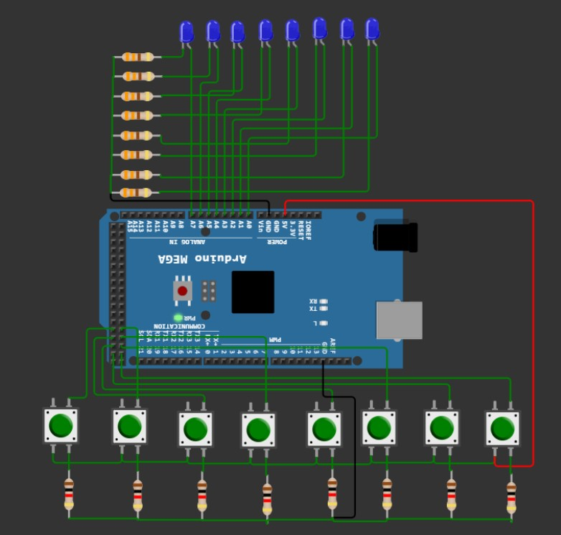
2. Press 2nd switch blink 8 LEDs:-  void setup() {  volatile char *dirf, *outf, *dira, *ina;  volatile long i;  volatile char x;  dirf=0x30; *dirf=0xff;  dira=0x21; *dira=0;  outf=0x31;  ina=0x20;  while(1){  x=*ina;  if(x==4){  while(1){  *outf=0xff;  for(i=0; i<100000; i++);  *outf=0;  for(i=0; i<100000; i++);  }  }  }  }  void loop() {} | 3. Press 3rd switch glow 0th LED, delay,1st LED, delay …:-  void setup() {  volatile char *dirf, *outf, *dira, *ina;  volatile long i;  volatile char x, a;  dirf=0x30; *dirf=0xff;  dira=0x21; *dira=0;  outf=0x31;  ina=0x20;  while(1){  *outf=0;  x=*ina;  if(x==8){  for(a=0; a<8; a++){  *outf= 1 << a;  for(i=0; i<100000; i++);  }  }  }  }  void loop() {}

4. Press any switch glow 7th LED, delay,6th LED, delay …:-  void setup() {  volatile char *dirf, *outf, *dira, *ina;  volatile long i;  volatile char x, a;  dirf=0x30; *dirf=0xff;  dira=0x21; *dira=0;  outf=0x31;  ina=0x20;  while(1){  *outf=0;  x=*ina;  if(x){  for(a=0; a<8; a++){  *outf= 128 >> a;  for(i=0; i<100000; i++);  }  }  }  }  void loop() {} | 5. Press 0th switch glow even LEDs:-  void setup() {  volatile char *dirf, *outf, *dira, *ina;  volatile long i;  volatile char x;  dirf=0x30; *dirf=0xff;  dira=0x21; *dira=0;  outf=0x31;  ina=0x20;  while(1){  *outf=0;  x=*ina;  if(x==1){  *outf=0x55;  for(i=0; i<500000; i++);  }  }  }  void loop() {}
6. Press 7th switch glow odd LEDs:-  void setup() {  volatile char *dirf, *outf, *dira, *ina;  volatile long i;  volatile short x;  dirf=0x30; *dirf=0xff;  dira=0x21; *dira=0x00;  outf=0x31;  ina=0x20;  while(1){  *outf=0;  x=*ina;  if((x & 128) == 128){  *outf=0xaa;  for(i=0; i<500000; i++);  }  }  }  void loop() {} | 7. Press 0th switch 0th LED should glow Press 1st switch 1st LED should glow …....up to 7th switch:-  void setup() {  volatile char *dirf, *outf, *dira, *ina;  volatile long i;  volatile long x;  dirf=0x30; *dirf=0xff;  dira=0x21; *dira=0x00;  outf=0x31;  ina=0x20;  while(1){  *outf=*ina;  }  }  void loop() {}

8. Press 0th switch 7th LED should glow …. Press 1st switch 6th LED should glow ….. ...........up to 7th switch:-  void setup() {  volatile char *dirf, *outf, *dira, *ina;  volatile short x;  dirf=0x30; *dirf=0xff;  dira=0x21; *dira=0x00;  outf=0x31;  ina=0x20;  while(1){  x=*ina;  if(x==1) *outf=128;  else if(x==2) *outf=64;  else if(x==4) *outf=32;  else if(x==8) *outf=16;  else if(x==16) *outf=8;  else if(x==32) *outf=4;  else if(x==64) *outf=2;  else if((x & 128)==128) *outf=1;  else *outf=0;  }  }  void loop() {} | 
9. Press any switch 0th LED ON, OFF 1st LED ON, OFF….:-  void setup() {  volatile char *dirf, *outf, *dira, *ina;  volatile long i;  volatile char a, x;  dirf=0x30; *dirf=0xff;  dira=0x21; *dira=0x00;  outf=0x31;  ina=0x20;  while(1){  *outf=0;  x=*ina;  if(x)  for(a=0; a<8; a++){  *outf= 1 << a;  for(i=0; i<100000; i++);  }  }  }  void loop() {} | 10. Press 1st switch At a time glow 0th LED,3rd LED, 4th LED,7th LED:-  void setup() {  volatile char *dirf, *outf, *dira, *ina;  volatile long i;  volatile char a, x;  dirf=0x30; *dirf=0xff;  dira=0x21; *dira=0x00;  outf=0x31;  ina=0x20;  while(1){  *outf=0;  x=*ina;  if(x){  *outf=153;  for(i=0; i<500000; i++);  }  }  }  void loop() {}

ESP - Switch Problems – Set 2
1. Press 2nd switch first glow 1st LED, delay, 2nd LED, delay, 5th LED, delay,6th LED:-  void setup() {  volatile char *dirf, *outf, *dira, *ina;  volatile char arr[]={2,4,32,64}, a;  volatile unsigned short x;  volatile long i;  dirf=0x30; *dirf=0xff;  dira=0x21; *dira=0x00;  outf=0x31;  ina=0x20;  while(1){  *outf=0;  x=*ina;  if(x==4)  for(a=0; a<4; a++){  *outf=arr[a];  for(i=0; i<500000; i++);  }  }  }  void loop() {} | 
2. Press 3rd switch first glow 3rd LED, delay, 1st LED, delay, 7th LED, delay,4th LED:-  void setup() {  volatile char *dirf, *outf, *dira, *ina;  volatile char arr[]={8,1,128,16}, a;  volatile unsigned short x;  volatile long i;  dirf=0x30; *dirf=0xff;  dira=0x21; *dira=0x00;  outf=0x31;  ina=0x20;  while(1){  *outf=0;  x=*ina;  if(x==8)  for(a=0; a<4; a++){  *outf=arr[a];  for(i=0; i<500000; i++);  }  }  }  void loop() {} | 3. Press 2nd switch glow 0th LED, delay, 1 st LED, delay, 5th LED, delay,6th LED:-  void setup() {  volatile char *dirf, *outf, *dira, *ina;  volatile char arr[]={1,2,32,64}, a;  volatile unsigned short x;  volatile long i;  dirf=0x30; *dirf=0xff;  dira=0x21; *dira=0x00;  outf=0x31;  ina=0x20;  while(1){  *outf=0;  x=*ina;  if(x==4)  for(a=0; a<4; a++){  *outf=arr[a];  for(i=0; i<500000; i++);  }  }  }  void loop() {}
4. Press 7th switch first glow 0th LED, delay, 1st LED, Delay, 4th LED, delay,7th LED:-  void setup() {  volatile char *dirf, *outf, *dira, *ina;  volatile char arr[]={1,2,16,128}, a;  volatile unsigned short x;  volatile long i;  dirf=0x30; *dirf=0xff;  dira=0x21; *dira=0x00;  outf=0x31;  ina=0x20;  while(1){  *outf=0;  x=*ina;  if((x & 128)==128)  for(a=0; a<4; a++){  *outf=arr[a];  for(i=0; i<500000; i++);  }  }  }  void loop() {} | 5. Press 3rd switch first glow 7th LED, delay, 6th LED, delay, 3rd LED, delay,2nd LED:-  void setup() {  volatile char *dirf, *outf, *dira, *ina;  volatile char arr[]={128,64,8,4}, a;  volatile unsigned short x;  volatile long i;  dirf=0x30; *dirf=0xff;  dira=0x21; *dira=0x00;  outf=0x31;  ina=0x20;  while(1){  *outf=0;  x=*ina;  if(x ==8)  for(a=0; a<4; a++){  *outf=arr[a];  for(i=0; i<500000; i++);  }  }  }  void loop() {}
6. Press 2nd switch first glow 3rd LED, delay, 5th LED, delay, 7th LED, delay,6th LED:-  void setup() {  volatile char *dirf, *outf, *dira, *ina;  volatile char arr[]={8,32,128,64}, a;  volatile unsigned short x;  volatile long i;  dirf=0x30; *dirf=0xff;  dira=0x21; *dira=0x00;  outf=0x31;  ina=0x20;  while(1){  *outf=0;  x=*ina;  if(x ==4)  for(a=0; a<4; a++){  *outf=arr[a];  for(i=0; i<500000; i++);  }  }  }  void loop() {} | 7. Press 7th switch first glow 5th LED, delay, 3rd LED, delay, 0th LED, delay,1st LED:-  void setup() {  volatile char *dirf, *outf, *dira, *ina;  volatile char arr[]={32,8,1,2}, a;  volatile unsigned short x;  volatile long i;  dirf=0x30; *dirf=0xff;  dira=0x21; *dira=0x00;  outf=0x31;  ina=0x20;  while(1){  *outf=0;  x=*ina;  if((x & 128) ==128)  for(a=0; a<4; a++){  *outf=arr[a];  for(i=0; i<500000; i++);  }  }  }  void loop() {}
8. Press 1st switch & Press 7th switch Together, Glow 5th LED for 30 seconds:-  void delays(char y);  void setup() {  volatile char *dirf, *outf, *dira, *ina;  volatile unsigned short x;  dirf=0x30; *dirf=0xff;  dira=0x21; *dira=0x00;  outf=0x31;  ina=0x20;  while(1){  *outf=0; x=*ina;  if(x==130){  *outf=32; delays(30);  } } }  void loop() {}  void delays(char y){ // delay(10); = 10 second delay;  volatile long i, j;  for(i=0; i<y; i++)  for(j=0; j<430000; j++);  } | 
9. Press 1st switch & Press 4th switch & Press 6th switch & Press 2nd switch One by One, Glow 7th LED for 10 seconds:-  void delays(char y);  void setup() {  volatile char *dirf, *outf, *dira, *ina;  dirf=0x30; *dirf=0xff;  dira=0x21; *dira=0x00;  outf=0x31; ina=0x20;  L1:  while(1) if(*ina==2)  while(1) if(*ina==16)  while(1) if(*ina==64)  while(1) if(*ina==4)  {  *outf=128; delays(10); *outf=0;  goto L1;  }  }  void loop() {}  void delays(char y){ // delay(10); = 10 second delay;  volatile long i, j;  for(i=0; i<y; i++)  for(j=0; j<430000; j++);  } | 10. Press 1st switch & Press 4th switch & Press 6th switch & Press 5th switch One by One, Glow 5th LED; Press 4th switch & Press 6th switch & Press 5th switch & Press 3th switch & One by One, OFF 5th LED:-  void delays(char y);  void setup() {  volatile char *dirf, *outf, *dira, *ina;  dirf=0x30; *dirf=0xff;  dira=0x21; *dira=0x00;  outf=0x31; ina=0x20;  L1: while(1) {  if(*ina==2){  while(1) if(*ina==16)  while(1) if(*ina==64)  while(1) if(*ina==32) {*outf=32; goto L1;}}  if(*ina==16){  while(1) if(*ina==64)  while(1) if(*ina==32)  while(1) if(*ina==8) {*outf=0; goto L1;}}  } }  void loop() {}

ESP – 7 Segment Problems – Set 1
01 Display 0 to 9 without decimal points:-  void setup() {  volatile char *dirf, *outf;  volatile char a[]={0x3f,0x06,0x5b,0x4f,0x66,  0x6d,0x7d,0x07,0x7f, 0x6f};  dirf=0x30;  *dirf=0xff;  outf=0x31;  volatile long i, j;  while(1) {  for(i=0; i<10; i++)  {  *outf=a[i];  for(j=0; j<300000; j++);  }  }  }  void loop() {} | 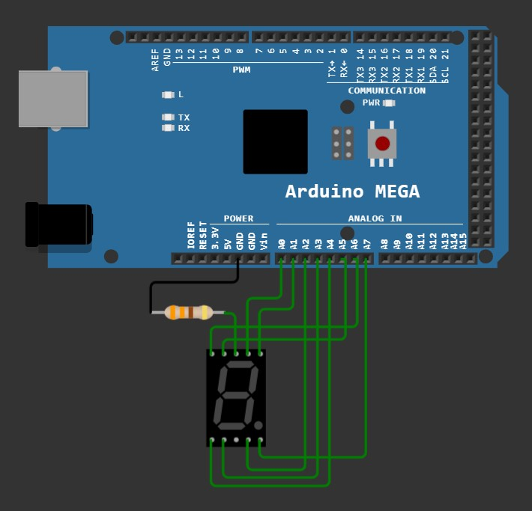
02 Display 0 to 9 with decimal points:-  void setup() {  volatile char *dirf, *outf;  volatile char a[]={0x3f,0x06,0x5b,0x4f,0x66,  0x6d,0x7d,0x07,0x7f, 0x6f};  dirf=0x30;  *dirf=0xff;  outf=0x31;  volatile long i, j;  while(1) {  for(i=0; i<10; i++)  {  *outf=a[i] + 128;  for(j=0; j<300000; j++);  }  }  }  void loop() {} | 03 Display 9 to 0 with delay:-  void setup() {  volatile char *dirf, *outf;  volatile char a[]={0x3f,0x06,0x5b,0x4f,0x66,  0x6d,0x7d,0x07,0x7f, 0x6f};  dirf=0x30;  *dirf=0xff;  outf=0x31;  volatile long i, j;  while(1) {  for(i=9; i>=0; i--)  {  *outf=a[i];  for(j=0; j<300000; j++);  }  }  }  void loop() {}

04 Display odd numbers with delay:-  void setup() {  volatile char *dirf, *outf;  volatile char arr[]={0x3f,0x06,0x5b,0x4f,0x66,  0x6d,0x7d,0x07,0x7f, 0x6f};  volatile char a;  volatile long i;  dirf=0x30;  *dirf=0xff;  outf=0x31;  while(1) {  for(a=1; a<10; a+=2)  {  *outf=arr[a];  for(i=0; i<300000; i++);  }  }  }  void loop() {} | 05 Display even numbers with delay:-  void setup() {  volatile char *dirf, *outf;  volatile char arr[]={0x3f,0x06,0x5b,0x4f,0x66,  0x6d,0x7d,0x07,0x7f, 0x6f};  volatile char a;  volatile long i;  dirf=0x30;  *dirf=0xff;  outf=0x31;  while(1) {  for(a=0; a<10; a+=2)  {  *outf=arr[a];  for(i=0; i<300000; i++);  }  }  }  void loop() {}
06 Display the possible alphabets ( A to Z):-  void setup() {  volatile char *dirf, *outf;  volatile char arr[]={0x77, 0x7c,0x58,0x5e,  0x79,0x71,0x40,0x76,0x06,0x0e,0x40,0x38,  0x40,0x80,0x5c,0x73,0x67,0x50,0x6d,0x40,  0x1c,0x40,0x80,0x40,0x80,0x40};  volatile char a;  volatile long i;  dirf=0x30;  *dirf=0xff;  outf=0x31;  for(a=0; a<26; a++)  {  *outf=arr[a];  for(i=0; i<500000; i++);  }  *outf=0;  }  void loop() {} | 07 Display numbers in following order: 0,2,4,6,8,9,7,5,3,1:-  void setup() {  volatile char *dirf, *outf;  volatile char arr[]={0x3f,0x5b,0x66,0x7d,0x7f,  0x6f,0x07,0x6d,0x4f, 0x06};  volatile char a;  volatile long i;  dirf=0x30;  *dirf=0xff;  outf=0x31;  while(1) {  for(a=0; a<10; a++)  {  *outf=arr[a];  for(i=0; i<300000; i++);  }  }  }  void loop() {}

08 Display the single digit prime numbers:-  void setup() {  volatile char *dirf, *outf;  volatile char arr[]={0x5b,0x4f,0x6d,0x07};  volatile long i;  volatile char a;  dirf=0x30;  *dirf=0xff;  outf=0x31;  while(1) {  for(a=0; a<4; a++)  {  *outf=arr[a];  for(i=0; i<300000; i++);  }  }  }  void loop() {} | 
09 Display last digit of a number. Assume any number.:-  void setup() {  volatile char *dirf, *outf;  dirf=0x30;  *dirf=0xff;  outf=0x31;  *outf=0x6d;  }  void loop() {} | 10 Display first digit of a number. Assume any number:-  void setup() {  volatile char *dirf, *outf;  dirf=0x30;  *dirf=0xff;  outf=0x31;  *outf=0x5b;  }  void loop() {}

ESP – 7 Segment Problems – Set 2
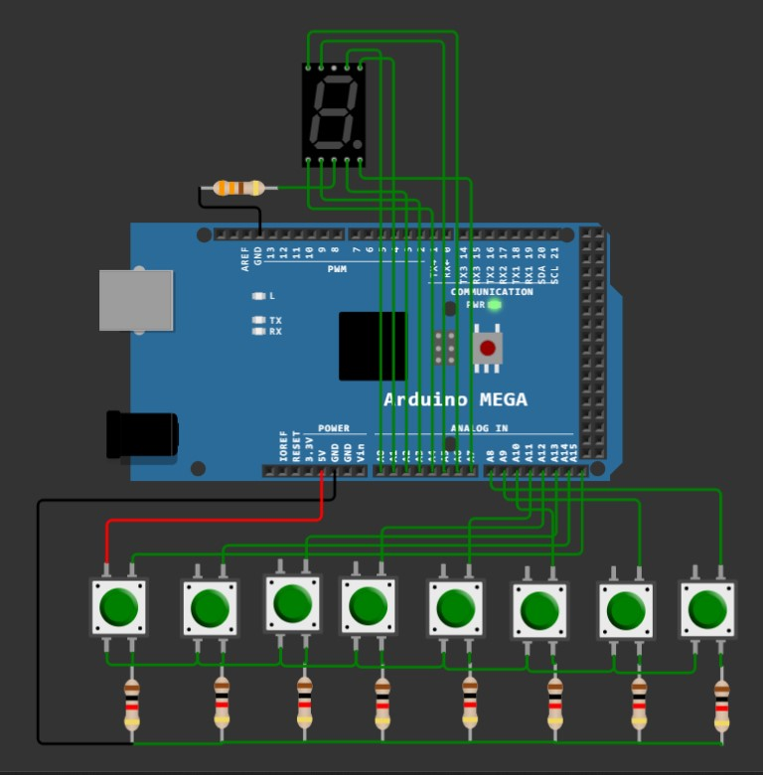  01 Press any switch & display that number. Ex: 1 - > 1, 2 ->2, … 8 -> 8:-  void delays(char y);  void setup() {  volatile char *dirf, *outf, *dirk, *ink;  volatile char arr[]={0x06,0x5b,0x4f,0x66,  0x6d,0x7d,0x07,0x7f};  volatile char a;  volatile unsigned short x;  dirf=0x30; *dirf=0xff; outf=0x31;  dirk=0x107; *dirk=0; ink=0x106;  while(1) {  x=*ink;  if(x)  for(a=0; a<8; a++)  {  *outf=arr[a]; delays(1);  *outf=0x40; delays(1);  *outf=arr[a]; delays(1);  }  *out=0;  }  }  void loop() {}  void delays(char y){ // delay(10); = 10 second delay;  volatile long i, j;  for(i=0; i<y; i++)  for(j=0; j<430000; j++);  } |   02 Press any switch & display the reverse order Ex: 1 -> 8, 2-> 7, 8 -> 1:-  void delays(char y);  void setup() {  volatile char *dirf, *outf, *dirk, *ink;  volatile char arr[]={0x06,0x5b,0x4f,0x66,  0x6d,0x7d,0x07,0x7f};  volatile char a, b;  volatile unsigned short x;  dirf=0x30; *dirf=0xff; outf=0x31;  dirk=0x107; *dirk=0; ink=0x106;  while(1) {  x=*ink;  if(x)  for(a=0, b=7; a<8; a++, b--){  *outf=arr[a]; delays(1);  *outf=0x40; delays(1);  *outf=arr[b]; delays(1);  }  *outf=0;  }  }  void loop() {}  void delays(char y){ // delay(10); = 10 second delay;  volatile long i, j;  for(i=0; i<y; i++)  for(j=0; j<430000; j++);  }
03 Press any switch & Display should start from that number till nine and restart from that number till 9. Continuous loop:-  void setup() {  volatile char *dirf, *outf, *dirk, *ink;  volatile char arr[]={0x3f,0x06,0x5b,0x4f,0x66,  0x6d,0x7d,0x07,0x7f, 0x6f};  volatile char a, b;  volatile long i;  volatile unsigned short x;  dirf=0x30; *dirf=0xff; outf=0x31;  dirk=0x107; *dirk=0; ink=0x106;  while(1) {  x=*ink;  if(x==1) a=0;  else if(x==1) a=0; else if(x==2) a=1;  else if(x==4) a=2; else if(x==8) a=3;  else if(x==16) a=4; else if(x==32) a=5;  else if(x==64) a=6; else if((x & 128)==128) a=7;  if(x) while(1){  for(b=a; b<10; b++){  *outf=arr[b];  for(i=0; i<200000; i++);  } }  }  }  void loop() {} | 04 Press switch 7 & display from 0 to 9 and 9 to 0 one time:-  void setup() {  volatile char *dirf, *outf, *dirk, *ink;  volatile char arr[]={0x3f,0x06,0x5b,0x4f,0x66,0x6d,0x7d,0x07,0x7f, 0x6f};  volatile char a;  volatile long i;  volatile unsigned short x;  dirf=0x30; *dirf=0xff; outf=0x31;  dirk=0x107; *dirk=0; ink=0x106;  while(1) {  x=*ink;  *outf=0;  if((x & 128)==128){  for(a=0; a<10; a++){  *outf=arr[a];  for(i=0; i<300000; i++);  }  for(a--; a>=0; a--){  *outf=arr[a];  for(i=0; i<300000; i++);  }  }  }  }  void loop() {}
05 Display A – F in a loop:-  void setup() {  volatile char *dirf, *outf, *dirk, *ink;  volatile char arr[]={0x77, 0x7c,0x58,0x5e,0x79,0x71};  volatile char a;  volatile long i;  dirf=0x30; *dirf=0xff; outf=0x31;  // dirk=0x107; *dirk=0; ink=0x106;  while(1) {  for(a=0; a<6; a++){  *outf=arr[a];  for(i=0; i<300000; i++);  }  }  }  void loop() {} | 06 Initially display 0. When switch 1 is pressed every time increment by 1:-  void setup() {  volatile char *dirf, *outf, *dirk, *ink;  volatile char arr[]={0x3f,0x06,0x5b,0x4f,0x66,  0x6d,0x7d,0x07,0x7f, 0x6f};  volatile char count=0;  volatile long i;  dirf=0x30; *dirf=0xff; outf=0x31;  dirk=0x107; *dirk=0; ink=0x106;  *outf=arr[count];  while(1) {  if(*ink==2){  count++;  *outf=arr[count];  for(i=0; i<100000; i++);  }  if(count==9) {count=0; count--;}  }  }  void loop() {}
07 Initially display 9. When switch 2 is pressed every time decrement by 1:-  void setup() {  volatile char *dirf, *outf, *dirk, *ink;  volatile char arr[]={0x3f,0x06,0x5b,0x4f,0x66,  0x6d,0x7d,0x07,0x7f, 0x6f};  volatile char count=9;  volatile long i;  dirf=0x30; *dirf=0xff; outf=0x31;  dirk=0x107; *dirk=0; ink=0x106;  *outf=arr[count];  while(1) {  if(*ink==4){  count--;  *outf=arr[count];  for(i=0; i<100000; i++);  }  if(count==0) count=10;  }  }  void loop() {} | 08 Initially display 0 When switch 1 is pressed start displaying 0 to 9 Continuously. When switch 2 is pressed stop display:-  void setup() {  volatile char *dirf, *outf, *dirk, *ink;  volatile char a, arr[]={0x3f,0x06,0x5b,0x4f,0x66,  0x6d,0x7d,0x07,0x7f, 0x6f};  volatile long i;  volatile char flag=0;  dirf=0x30; *dirf=0xff; outf=0x31;  dirk=0x107; *dirk=0; ink=0x106;  while(1) {  *outf=0x3f; if(*ink==2)  while(1){  for(a=0; a<10; a++){  *outf=arr[a]; for(i=0; i<300000; i++)  if(*ink==4) flag=1;  if(flag==1) break;  }  if(flag==1){flag=0; break;}  } } }  void loop() {}
09 Initially display 9 When switch 1 is pressed start displaying 9 to 0 Continuously. When Switch 2 is pressed stop display:-  void setup() {  volatile char *dirf, *outf, *dirk, *ink;  volatile char a, arr[]={0x3f,0x06,0x5b,0x4f,0x66,  0x6d,0x7d,0x07,0x7f, 0x6f};  volatile long i;  volatile char flag=0;  dirf=0x30; *dirf=0xff; outf=0x31;  dirk=0x107; *dirk=0; ink=0x106;  while(1) {  *outf=0x6f;  if(*ink==2)  while(1){  for(a=9; a>=0; a--){  *outf=arr[a];  for(i=0; i<300000; i++)  if(*ink==4) flag=1;  if(flag==1) break;  }  if(flag==1){flag=0; break;}  } } }  void loop() {} | 10 Get a 4 digit number from user (Press the switch Sequentially (Example 1256) Add the sum of Them the sum is more than 1 digit then add them again and show the sum on display:-  void setup() {  volatile char *dirf, *outf, *dirk, *ink;  volatile char a, arr[]={0x3f,0x06,0x5b,0x4f,0x66,  0x6d,0x7d,0x07,0x7f, 0x6f};  volatile char count=0, x, sum=0;  dirf=0x30; *dirf=0xff; outf=0x31;  dirk=0x107; *dirk=0; ink=0x106;  volatile long i;  while(1){  x=*ink;  if(x==1) a=0; else if(x==2) a=1; else if(x==4) a=2;  else if(x==8) a=3; else if(x==16) a=4; else if(x==32) a=5;  else if(x==64) a=6; else if((x & 128)==128) a=7;  if(x){  sum+=a; count++;  for(i=0; i<90000; i++); }  if(count==4) break;  }  while(sum>9){ sum=(sum/10) + (sum%10); }  *outf=arr[sum];  }  void loop() {}
01 Display 00 to 99 in loop with delay:-  void setup() {  volatile char *dirf, *outf, *dirk, *outk;  volatile char arr[]={0x3f,0x06,0x5b,0x4f,0x66,  0x6d,0x7d,0x07,0x7f, 0x6f};  dirf=0x30; *dirf=0xff; outf=0x31;  dirk=0x107; *dirk=0xff; outk=0x108;  volatile long i;  volatile char a, b;  while(1) {  for(a=0; a<10; a++)  for(b=0; b<10; b++)  {  *outf=arr[a];  *outk=arr[b];  for(i=0; i<300000; i++);  }  }  }  void loop() {} | 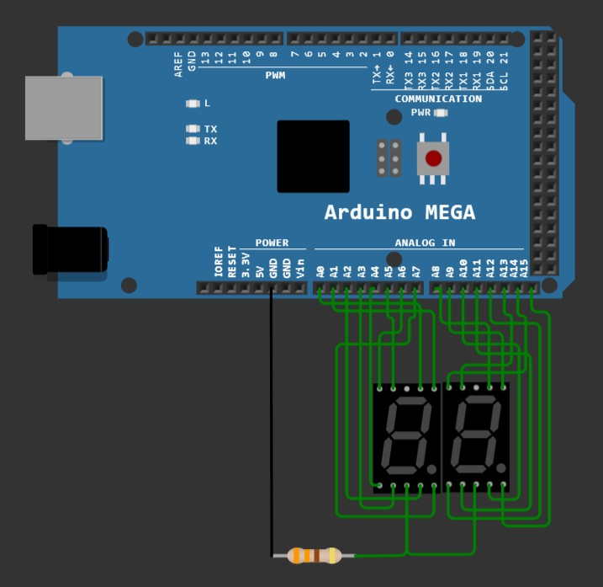  Connect TWO 7-Segment Displays to 2 individual ports
02 Display 0.0 to 9.9 in loop with delay:-  void setup() {  volatile char *dirf, *outf, *dirk, *outk;  volatile char arr[]={0x3f,0x06,0x5b,0x4f,0x66,  0x6d,0x7d,0x07,0x7f, 0x6f};  dirf=0x30; *dirf=0xff; outf=0x31;  dirk=0x107; *dirk=0xff; outk=0x108;  volatile long i;  volatile char a, b;  while(1) {  for(a=0; a<10; a++)  for(b=0; b<10; b++)  {  *outf=arr[a] + 128;  *outk=arr[b];  for(i=0; i<300000; i++);  }  }  }  void loop() {} | 03 Display 99 to 00 in loop with delay:-  void setup() {  volatile char *dirf, *outf, *dirk, *outk;  volatile char arr[]={0x3f,0x06,0x5b,0x4f,0x66,  0x6d,0x7d,0x07,0x7f, 0x6f};  dirf=0x30; *dirf=0xff; outf=0x31;  dirk=0x107; *dirk=0xff; outk=0x108;  volatile long i;  volatile char a, b;  while(1) {  for(a=9; a>=0; a--)  for(b=9; b>=0; b--)  {  *outf=arr[a];  *outk=arr[b];  for(i=0; i<300000; i++);  }  }  }  void loop() {}
ESP – 7 Segment Problems – Set 3
04 Display 9.9 to 0.0 in loop with delay:-  void setup() {  volatile char *dirf, *outf, *dirk, *outk;  volatile char arr[]={0x3f,0x06,0x5b,0x4f,0x66,  0x6d,0x7d,0x07,0x7f, 0x6f};  dirf=0x30; *dirf=0xff; outf=0x31;  dirk=0x107; *dirk=0xff; outk=0x108;  volatile long i;  volatile char a, b;  while(1) {  for(a=9; a>=0; a--)  for(b=9; b>=0; b--)  {  *outf=arr[a] + 128;  *outk=arr[b];  for(i=0; i<300000; i++);  }  }  }  void loop() {} |   Connect TWO 7-Segment Displays to 2 individual ports
05 Display 0000 to 9999 in loop with delay:-  void setup() {  volatile char *dirf, *outf, *dirk, *outk, *dira,  *outa, *dirc, *outc;  volatile char arr[]={0x3f,0x06,0x5b,0x4f,0x66,  0x6d,0x7d,0x07,0x7f, 0x6f};  dirf=0x30; *dirf=0xff; outf=0x31;  dirk=0x107; *dirk=0xff; outk=0x108;  dira=0x21; *dira=0xff; outa=0x22;  dirc=0x27; *dirc=0xff; outc=0x28;  volatile long i;  volatile char a, b, c, d;  while(1) {  for(a=0; a<10; a++)  for(b=0; b<10; b++)  for(c=0; c<10; c++)  for(d=0; d<10; d++)  {  *outf=arr[a];  *outk=arr[b];  *outa=arr[c];  *outc=arr[d];  for(i=0; i<50000; i++);  }  }  }  void loop() {} | 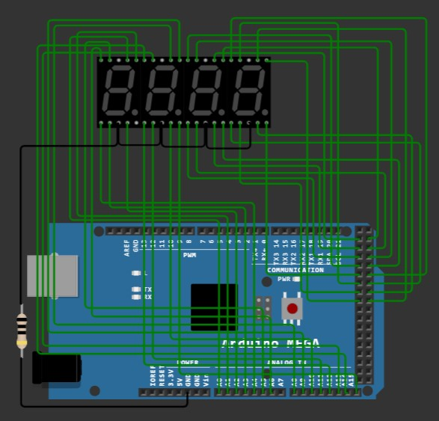  Connect FOUR 7-Segment Displays to 4 individual ports
06 Display 0.000 to 999.9 in loop with delay:-  void setup() {  volatile char *dirf, *outf, *dirk, *outk, *dira,  *outa, *dirc, *outc;  volatile char arr[]={0x3f,0x06,0x5b,0x4f,0x66,  0x6d,0x7d,0x07,0x7f, 0x6f};  dirf=0x30; *dirf=0xff; outf=0x31;  dirk=0x107; *dirk=0xff; outk=0x108;  dira=0x21; *dira=0xff; outa=0x22;  dirc=0x27; *dirc=0xff; outc=0x28;  volatile long i;  volatile char a, b, c, d;  volatile char count=0, m, n, o, p;  while(1) {  if(count==0){m=128; n=0; o=0; p=0;}  if(count==1){m=0; n=128; o=0; p=0;}  if(count==2){m=0; n=0; o=128; p=0;}  if(count==3){m=0; n=0; o=0; p=128;}  for(a=0; a<10; a++)  for(b=0; b<10; b++)  for(c=0; c<10; c++)  for(d=0; d<10; d++)  {  *outf=arr[a] + m;  *outk=arr[b] + n;  *outa=arr[c] + o;  *outc=arr[d] + p;  for(i=0; i<1000; i++);  }  count++;  if(count==4) goto end;  }  end:  *outf=0; *outk=0; *outa=0; *outc=0;  }  void loop() {} | 07 Display 0 to 9999 in loop with delay. Do not display the prefix 0 :-  void setup() {  volatile char *dirf, *outf, *dirk, *outk, *dira,  *outa, *dirc, *outc;  volatile char arr[]={0x00, 0x3f,0x06,0x5b,0x4f,0x66,  0x6d,0x7d,0x07,0x7f, 0x6f};  dirf=0x30; *dirf=0xff; outf=0x31;  dirk=0x107; *dirk=0xff; outk=0x108;  dira=0x21; *dira=0xff; outa=0x22;  dirc=0x27; *dirc=0xff; outc=0x28;  volatile long i, count=0;  volatile char a, b, c, d;  volatile char m, n, o, p;  while(1) {  for(a=1; a<=10; a++)  for(b=1; b<=10; b++)  for(c=1; c<=10; c++)  for(d=1; d<=10; d++)  {  if(count>=1000) {m=1; n=1; o=1; p=1;}  else if(count>=100) {m=0; n=1; o=1; p=1;}  else if(count>=10) {m=0; n=0; o=1; p=1;}  else if(count>=1) {m=0; n=0; o=0; p=1;}  *outf=arr[a*m];  *outk=arr[b*n];  *outa=arr[c*o];  *outc=arr[d*p];  for(i=0; i<300000; i++);  count++;  if(count>10000) goto end;  }  }  end:  *outf=0; *outk=0; *outa=0; *outc=0;  }  void loop() {}

08 Display 9999 to 0 in loop with delay. Do not display the prefix 0 :-  void setup() {  volatile char *dirf, *outf, *dirk, *outk, *dira, *outa,  *dirc, *outc;  volatile char arr[]={0x00, 0x3f,0x06,0x5b,0x4f,0x66,  0x6d,0x7d,0x07,0x7f, 0x6f};  dirf=0x30; *dirf=0xff; outf=0x31;  dirk=0x107; *dirk=0xff; outk=0x108;  dira=0x21; *dira=0xff; outa=0x22;  dirc=0x27; *dirc=0xff; outc=0x28;  volatile long i, count=9999;  volatile char a, b, c, d;  volatile char m, n, o, p;  while(1) {  for(a=10; a>0; a--)  for(b=10; b>0; b--)  for(c=10; c>0; c--)  for(d=10; d>0; d--)  {  if(count<10) {m=0; n=0; o=0; p=1;}  else if(count<100) {m=0; n=0; o=1; p=1;}  else if(count<1000) {m=0; n=1; o=1; p=1;}  else if(count<10000) {m=1; n=1; o=1; p=1;}  *outf=arr[a*m];  *outk=arr[b*n];  *outa=arr[c*o];  *outc=arr[d*p];  for(i=0; i<1000; i++);  count--;  if(count==0) goto end;  }  }  end:  *outf=0; *outk=0; *outa=0; *outc=0;  }  void loop() {} | 09 Display the two-digit prime numbers in loop :-  void setup() {  volatile char *dirf, *outf, *dirk, *outk;// *dira,  *outa, *dirc, *outc;  volatile char arr[]={0x3f,0x06,0x5b,0x4f,0x66,  0x6d,0x7d,0x07,0x7f, 0x6f};  dirf=0x30; *dirf=0xff; outf=0x31;  dirk=0x107; *dirk=0xff; outk=0x108;  //dira=0x21; *dira=0xff; outa=0x22;  // dirc=0x27; *dirc=0xff; outc=0x28;  volatile char a, b, prime, ones, tens;  volatile long i;  for(a=10; a<100; a++)  {  for(b=2; b<a; b++)  if((a%b)==0) {prime=0; break;}  else prime=a;  if(prime){  ones=prime%10;  tens=prime/10;  *outk=arr[ones];  *outf=arr[tens];  for(i=0; i<500000; i++);  }  }  *outf=0;  *outk=0;  }  void loop() {}

10 Display a clock (Min & Sec only) :-
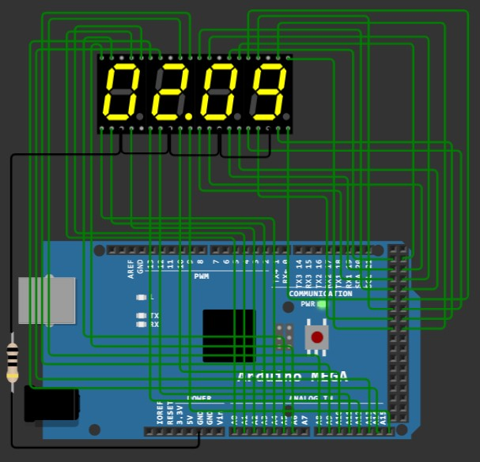

void setup() {
volatile char *dirf, *outf, *dirk, *outk, *dira, *outa, *dirc, *outc;
volatile char arr[]={0x3f,0x06,0x5b,0x4f,0x66,0x6d,0x7d,0x07,0x7f, 0x6f};
dirf=0x30; *dirf=0xff; outf=0x31;
dirk=0x107; *dirk=0xff; outk=0x108;
dira=0x21; *dira=0xff; outa=0x22;
dirc=0x27; *dirc=0xff; outc=0x28;

volatile char a, b, c, d;

for(a=0; a<6; a++)
for(b=0; b<10; b++)
for(c=0; c<6; c++)
for(d=0; d<10; d++)
{
*outf=arr[a];
*outk=arr[b] + 128;
*outa=arr[c];
*outc=arr[d];

delay(1000);
}
*outf=0; *outk=0; *outa=0; *outc=0;
}

void loop() {}

ESP – Keypad – Problems Set - 1
01 Press any switch & display that number. Ex: 1 - > 1, 2 ->2, … 8 -> 8,9 -> 9,0 -> 0 :-  volatile char *dirf, *outf, *dirk, *outk, *dira, *outa,  *dirc, *inc;  volatile char checkKey();  void display(volatile char m);  void init();  void setup() {  volatile char key;  init();  while(1){  key=checkKey();  display(key);  }  }  void display(volatile char number){  volatile char arr[]={0x3f,0x06,0x5b,0x4f,0x66,0x6d,  0x7d,0x07,0x7f, 0x6f, 0x40};  volatile char a, b, d4=~1, d3=~2, d2=~4, d1=~8, clr=~16;  volatile long i;  if(number){  for(a=number, b=number; a<(number+11); a++, b++){  if(b==10) b=0;  *outk=d4;  *outf=arr[b];  for(i=0; i<200000; i++);  }  }  }  volatile char checkKey(){  volatile char row, col, key;  for(row=0; row<4; row++){  *outa= 1 << row;  if(*inc){ col=*inc; break;}  }  if(row==0){  if(col==1) key=1;  else if(col==2) key=2;  else if(col==4) key=3;  else if(col==8) key=20;  }  else if(row==1){  if(col==1) key=4;  else if(col==2) key=5;  else if(col==4) key=6;  else if(col==8) key=21;  }  else if(row==2){  if(col==1) key=7;  else if(col==2) key=8;  else if(col==4) key=9;  else if(col==8) key=22;  }  else if(row==3){  if(col==1) key=26;  else if(col==2) key=25;  else if(col==4) key=24;  else if(col==8) key=23;  }  else key=0;  return key;  }  void init(){  dira=0x21; *dira=0xff; outa=0x22;  dirc=0x27; *dirc=0; inc=0x26;  dirf=0x30; *dirf=0xff; outf=0x31;  dirk=0x107; *dirk=0xff; outk=0x108;  }  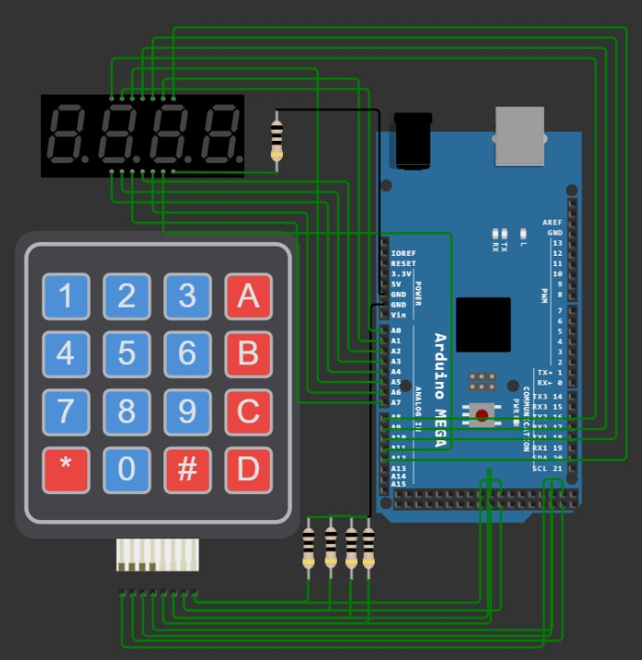  void loop() {} | 02 Press 4 digits and display that Number. Ex: 1234,6754, 9870, etc :-  volatile char checkKey();  void calculation(volatile char key);  void display();  void init();  volatile char *dirf, *outf, *dirk, *outk, *dira, *outa,  *dirc, *inc;  volatile char ones, tens, hundred, thousand;  volatile char flag=0;  volatile short number=0;  void setup() {  volatile char key;  volatile long i;  init();  while(1){  key=checkKey();  if(key){  for(i=0; i<10000; i++) display();  calculation(key);  }  display();  }  }  void calculation(volatile char key){  if(key=='0') key=0;  if (number==0) number=key;  else number = (number*10) + key;  number%=10000;  thousand=number/1000;  hundred=(number%1000)/100;  tens=(number%100)/10;  ones=number%10;  }  void display(){  if(flag==1) goto level;  volatile char arr[]={0x3f,0x06,0x5b,0x4f,0x66,0x6d,  0x7d,0x07,0x7f, 0x6f, 0x40};  volatile char d4=~1, d3=~2, d2=~4, d1=~8, clr=~16;  flag=1;  level:  *outk=d4; *outf=arr[thousand]; *outk=d4; *outf=0;  *outk=d3; *outf=arr[hundred]; *outk=d3; *outf=0;  *outk=d2; *outf=arr[tens]; *outk=d2; *outf=0;  *outk=d1; *outf=arr[ones]; *outk=d1; *outf=0;  }  volatile char checkKey(){  volatile char row, col, key;  for(row=0; row<4; row++){  *outa= 1 << row;  if(*inc){ col=*inc; break;}  }  if(row==0){  if(col==1) key=1;  else if(col==2) key=2;  else if(col==4) key=3;  else if(col==8) key='+';  }  else if(row==1){  if(col==1) key=4;  else if(col==2) key=5;  else if(col==4) key=6;  else if(col==8) key='-';  }  else if(row==2){  if(col==1) key=7;  else if(col==2) key=8;  else if(col==4) key=9;  else if(col==8) key='*';  }  else if(row==3){  if(col==1) key='c';  else if(col==2) key='0';  else if(col==4) key='=';  else if(col==8) key='/';  }  else key=0;  return key;  }  void init(){  dira=0x21; *dira=0xff; outa=0x22;  dirc=0x27; *dirc=0; inc=0x26;  dirf=0x30; *dirf=0xff; outf=0x31;  dirk=0x107; *dirk=0xff; outk=0x108;  }  void loop() {}

03 Perform Single Digit Addition Ex: 6 + 7 = 13, 9 + 4 = 13 :-  volatile char checkKey();  void calculation(volatile char key);  void display();  void init();  volatile char *dirf, *outf, *dirk, *outk, *dira, *outa,  *dirc, *inc;  volatile char ones, tens, hundred, thousand;  volatile char flag=0;  volatile short number=0, num1, num2;  void setup() {  volatile char key;  volatile long i;  init();  while(1){  key=checkKey();  if(key){  for(i=0; i<10000; i++) display();  calculation(key);  }  display();  }  }  void calculation(volatile char key){  if(key=='0') key=0;  if(key=='+' || key=='-' || key=='*' || key=='/'){ num1=number; number=0;}  else if(key=='='){ num2=number; number=num1+num2;}  else number=key;  if(key=='c') number=num1=num2=0;  number%=100;  tens=number/10;  ones=number%10;  }  void display(){  if(flag==1) goto level;  volatile char arr[]={0x3f,0x06,0x5b,0x4f,0x66,0x6d,  0x7d,0x07,0x7f, 0x6f, 0x40};  volatile char d4=~1, d3=~2, d2=~4, d1=~8, clr=~16;  flag=1;  level:  *outk=d4; *outf=arr[thousand]; *outk=d4; *outf=0;  *outk=d3; *outf=arr[hundred]; *outk=d3; *outf=0;  *outk=d2; *outf=arr[tens]; *outk=d2; *outf=0;  *outk=d1; *outf=arr[ones]; *outk=d1; *outf=0;  }  volatile char checkKey(){  volatile char row, col, key;  for(row=0; row<4; row++){  *outa= 1 << row;  if(*inc){ col=*inc; break;}  }  if(row==0){  if(col==1) key=1;  else if(col==2) key=2;  else if(col==4) key=3;  else if(col==8) key='+';  }  else if(row==1){  if(col==1) key=4;  else if(col==2) key=5;  else if(col==4) key=6;  else if(col==8) key='-';  }  else if(row==2){  if(col==1) key=7;  else if(col==2) key=8;  else if(col==4) key=9;  else if(col==8) key='*';  }  else if(row==3){  if(col==1) key='c';  else if(col==2) key='0';  else if(col==4) key='=';  else if(col==8) key='/';  }  else key=0;  return key;  }  void init(){  dira=0x21; *dira=0xff; outa=0x22;  dirc=0x27; *dirc=0; inc=0x26;  dirf=0x30; *dirf=0xff; outf=0x31;  dirk=0x107; *dirk=0xff; outk=0x108;  }  void loop() {} | 04 Perform Two Digit Addition Ex: 61 + 72 = 133, 19 + 42 = 61 :-  volatile char checkKey();  void calculation(volatile char key);  void display();  void init();  volatile char *dirf, *outf, *dirk, *outk, *dira, *outa,  *dirc, *inc;  volatile char ones, tens, hundred, thousand;  volatile char flag=0;  volatile short number=0, num1, num2;  void setup() {  volatile char key;  volatile long i;  init();  while(1){  key=checkKey();  if(key){  for(i=0; i<10000; i++) display();  calculation(key);  }  display();  }  }  void calculation(volatile char key){  if(key=='0') key=0;  if(key=='+' || key=='-' || key=='*' || key=='/'){ num1=number; number=0;}  else if(key=='='){ num2=number; number=num1+num2;}  else if(number==0) number=key;  else number = (number*10) + key;  if(key=='c') number=num1=num2=0;  if(key=='=') number%=1000;  else number%=100;  hundred=number/100;  tens=(number%100)/10;  ones=number%10;  }  void display(){  if(flag==1) goto level;  volatile char arr[]={0x3f,0x06,0x5b,0x4f,0x66,0x6d,  0x7d,0x07,0x7f, 0x6f, 0x40};  volatile char d4=~1, d3=~2, d2=~4, d1=~8, clr=~16;  flag=1;  level:  *outk=d4; *outf=arr[thousand]; *outk=d4; *outf=0;  *outk=d3; *outf=arr[hundred]; *outk=d3; *outf=0;  *outk=d2; *outf=arr[tens]; *outk=d2; *outf=0;  *outk=d1; *outf=arr[ones]; *outk=d1; *outf=0;  }  volatile char checkKey(){  volatile char row, col, key;  for(row=0; row<4; row++){  *outa= 1 << row;  if(*inc){ col=*inc; break;}  }  if(row==0){  if(col==1) key=1;  else if(col==2) key=2;  else if(col==4) key=3;  else if(col==8) key='+';  }  else if(row==1){  if(col==1) key=4;  else if(col==2) key=5;  else if(col==4) key=6;  else if(col==8) key='-';  }  else if(row==2){  if(col==1) key=7;  else if(col==2) key=8;  else if(col==4) key=9;  else if(col==8) key='*';  }  else if(row==3){  if(col==1) key='c';  else if(col==2) key='0';  else if(col==4) key='=';  else if(col==8) key='/';  }  else key=0;  return key;  }  void init(){  dira=0x21; *dira=0xff; outa=0x22;  dirc=0x27; *dirc=0; inc=0x26;  dirf=0x30; *dirf=0xff; outf=0x31;  dirk=0x107; *dirk=0xff; outk=0x108;  }  void loop() {}

05 Perform three Digit Addition. Ex: 161 + 656 = 817 659 + 765 = 1424 :-  volatile char checkKey();  void calculation(volatile char key);  void display();  void init();  volatile char *dirf, *outf, *dirk, *outk, *dira, *outa,  *dirc, *inc;  volatile char ones, tens, hundred, thousand;  volatile char flag=0;  volatile short number=0, num1, num2;  void setup() {  volatile char key;  volatile long i;  init();  while(1){  key=checkKey();  if(key){  for(i=0; i<10000; i++) display();  calculation(key);  }  display();  } }  void calculation(volatile char key){  if(key=='0') key=0;  if(key=='+' || key=='-' || key=='*' || key=='/'){ num1=number; number=0;}  else if(key=='='){ num2=number; number=num1+num2;}  else if(number==0) number=key;  else number = (number*10) + key;  if(key=='c') number=num1=num2=0;  if(key=='=') number%=10000;  else number%=1000;  thousand=number/1000;  hundred=(number%1000)/100;  tens=(number%100)/10;  ones=number%10;  }  void display(){  if(flag==1) goto level;  volatile char arr[]={0x3f,0x06,0x5b,0x4f,0x66,0x6d,  0x7d,0x07,0x7f, 0x6f, 0x40};  volatile char d4=~1, d3=~2, d2=~4, d1=~8, clr=~16;  flag=1;  level:  *outk=d4; *outf=arr[thousand]; *outk=d4; *outf=0;  *outk=d3; *outf=arr[hundred]; *outk=d3; *outf=0;  *outk=d2; *outf=arr[tens]; *outk=d2; *outf=0;  *outk=d1; *outf=arr[ones]; *outk=d1; *outf=0;  }  volatile char checkKey(){  volatile char row, col, key;  for(row=0; row<4; row++){  *outa= 1 << row;  if(*inc){ col=*inc; break;}  }  if(row==0){  if(col==1) key=1;  else if(col==2) key=2;  else if(col==4) key=3;  else if(col==8) key='+';  }  else if(row==1){  if(col==1) key=4;  else if(col==2) key=5;  else if(col==4) key=6;  else if(col==8) key='-';  }  else if(row==2){  if(col==1) key=7;  else if(col==2) key=8;  else if(col==4) key=9;  else if(col==8) key='*';  }  else if(row==3){  if(col==1) key='c';  else if(col==2) key='0';  else if(col==4) key='=';  else if(col==8) key='/';  }  else key=0;  return key;  }  void init(){  dira=0x21; *dira=0xff; outa=0x22;  dirc=0x27; *dirc=0; inc=0x26;  dirf=0x30; *dirf=0xff; outf=0x31;  dirk=0x107; *dirk=0xff; outk=0x108;  }  void loop() {} | 06 Perform any digit Addition. If the total exceeds 9999 then display “EEEE” Ex: 1561 + 2 = 1563, 8765 + 987 = 9752 :-  volatile char checkKey();  void calculation(volatile char key);  void display();  void init();  volatile char *dirf, *outf, *dirk, *outk, *dira, *outa,  *dirc, *inc;  volatile char ones, tens, hundred, thousand;  volatile char flag=0;  volatile long number=0, temp, num1, num2;  void setup() {  volatile char key;  volatile long i;  init();  while(1){  key=checkKey();  if(key){  for(i=0; i<10000; i++) display();  calculation(key);  }  display();  } }  void calculation(volatile char key){  if(key=='0') key=0;  if(key=='+' || key=='-' || key=='*' || key=='/'){ num1=number; number=0;}  else if(key=='='){ num2=number; number=num1+num2;}  else if(number==0) number=key;  else number = (number*10) + key;  if(key=='c') number=num1=num2=0;  if(key=='=' && number>9999){thousand=hundred=tens=ones=10; goto level;}  temp=number;  temp%=10000;  thousand=temp/1000;  hundred=(temp%1000)/100;  tens=(temp%100)/10;  ones=temp%10;  level:;  }  void display(){  if(flag==1) goto level;  volatile char arr[]={0x3f,0x06,0x5b,0x4f,0x66,0x6d,  0x7d,0x07,0x7f, 0x6f, 0x79};  volatile char d4=~1, d3=~2, d2=~4, d1=~8, clr=~16;  flag=1;  level:  *outk=d4; *outf=arr[thousand]; *outk=d4; *outf=0;  *outk=d3; *outf=arr[hundred]; *outk=d3; *outf=0;  *outk=d2; *outf=arr[tens]; *outk=d2; *outf=0;  *outk=d1; *outf=arr[ones]; *outk=d1; *outf=0;  }  volatile char checkKey(){  volatile char row, col, key;  for(row=0; row<4; row++){  *outa= 1 << row;  if(*inc){ col=*inc; break;}  }  if(row==0){  if(col==1) key=1;  else if(col==2) key=2;  else if(col==4) key=3;  else if(col==8) key='+';  }  else if(row==1){  if(col==1) key=4;  else if(col==2) key=5;  else if(col==4) key=6;  else if(col==8) key='-';  }  else if(row==2){  if(col==1) key=7;  else if(col==2) key=8;  else if(col==4) key=9;  else if(col==8) key='*';  }  else if(row==3){  if(col==1) key='c';  else if(col==2) key='0';  else if(col==4) key='=';  else if(col==8) key='/';  }  else key=0;  return key;  }  void init(){  dira=0x21; *dira=0xff; outa=0x22;  dirc=0x27; *dirc=0; inc=0x26;  dirf=0x30; *dirf=0xff; outf=0x31;  dirk=0x107; *dirk=0xff; outk=0x108;  }  void loop() {}

07 Perform any digit Subtraction. If the total exceeds 9999 then display “EEEE”. Display Negative result also. Ex: 1561 - 2 = 1559, 765 - 987 = -22 :-  volatile char checkKey();  void calculation(volatile char key);  void display();  void init();  volatile char *dirf, *outf, *dirk, *outk, *dira, *outa,  *dirc, *inc;  volatile char ones, tens, hundred, thousand;  volatile char flag=0;  volatile long number=0, temp, num1, num2, negative;  void setup() {  volatile char key;  volatile long i;  init();  while(1){  key=checkKey();  if(key){  for(i=0; i<10000; i++) display();  calculation(key); }  display();  } }  void calculation(volatile char key){  if(key=='0') key=0;  if(key=='+' || key=='-' || key=='*' || key=='/'){ num1=number; number=0;}  else if(key=='='){ num2=number; number=num1-num2;}  else if(number==0) number=key;  else number = (number*10) + key;  if(key=='c') {number=num1=num2=0; negative=0;}  if(key=='=' && number>9999){thousand=hundred=tens=ones=10; goto level;}  if(number<0){negative=number; number-=1; number = ~number;} // For -ve value to +ve value conversion  temp=number;  temp%=10000;  if(negative<0 && number<999) thousand=11;  else thousand=temp/1000;  hundred=(temp%1000)/100;  tens=(temp%100)/10;  ones=temp%10;  level:;  }  void display(){  if(flag==1) goto level;  volatile char arr[]={0x3f,0x06,0x5b,0x4f,0x66,0x6d,  0x7d,0x07,0x7f, 0x6f, 0x79, 0x40};  volatile char d4=~1, d3=~2, d2=~4, d1=~8, clr=~16;  flag=1;  level:  *outk=d4; *outf=arr[thousand]; *outk=d4; *outf=0;  *outk=d3; *outf=arr[hundred]; *outk=d3; *outf=0;  *outk=d2; *outf=arr[tens]; *outk=d2; *outf=0;  *outk=d1; *outf=arr[ones]; *outk=d1; *outf=0;  }  volatile char checkKey(){  volatile char row, col, key;  for(row=0; row<4; row++){  *outa= 1 << row;  if(*inc){ col=*inc; break;}  }  if(row==0){  if(col==1) key=1;  else if(col==2) key=2;  else if(col==4) key=3;  else if(col==8) key='+';  }  else if(row==1){  if(col==1) key=4;  else if(col==2) key=5;  else if(col==4) key=6;  else if(col==8) key='-';  }  else if(row==2){  if(col==1) key=7;  else if(col==2) key=8;  else if(col==4) key=9;  else if(col==8) key='*';  }  else if(row==3){  if(col==1) key='c';  else if(col==2) key='0';  else if(col==4) key='=';  else if(col==8) key='/';  }  else key=0;  return key;  }  void init(){  dira=0x21; *dira=0xff; outa=0x22;  dirc=0x27; *dirc=0; inc=0x26;  dirf=0x30; *dirf=0xff; outf=0x31;  dirk=0x107; *dirk=0xff; outk=0x108;  }  void loop() {} | 08 Perform any digit Multiplication. If the total exceeds 9999 then display “EEEE”. Ex: 25 x 40 = 1000, 1111 x 8 = 8888 :-  volatile char checkKey();  void calculation(volatile char key);  void display();  void init();  volatile char *dirf, *outf, *dirk, *outk, *dira, *outa,  *dirc, *inc;  volatile char ones, tens, hundred, thousand;  volatile char flag=0;  volatile short number=0, temp, num1, num2;  void setup() {  volatile char key;  volatile long i;  init();  while(1){  key=checkKey();  if(key){  for(i=0; i<10000; i++) display();  calculation(key);  }  display();  } }  void calculation(volatile char key){  if(key=='0') key=0;  if(key=='+' || key=='-' || key=='*' || key=='/'){ num1=number; number=0;}  else if(key=='='){ num2=number; number=num1*num2;}  else if(number==0) number=key;  else number = (number*10) + key;  if(key=='c') number=num1=num2=0;  if(key=='=' && number>9999){thousand=hundred=tens=ones=10; goto level;}  temp=number;  temp%=10000;  thousand=temp/1000;  hundred=(temp%1000)/100;  tens=(temp%100)/10;  ones=temp%10;  level:;  }  void display(){  if(flag==1) goto level;  volatile char arr[]={0x3f,0x06,0x5b,0x4f,0x66,0x6d,  0x7d,0x07,0x7f, 0x6f, 0x79};  volatile char d4=~1, d3=~2, d2=~4, d1=~8, clr=~16;  flag=1;  level:  *outk=d4; *outf=arr[thousand]; *outk=d4; *outf=0;  *outk=d3; *outf=arr[hundred]; *outk=d3; *outf=0;  *outk=d2; *outf=arr[tens]; *outk=d2; *outf=0;  *outk=d1; *outf=arr[ones]; *outk=d1; *outf=0;  }  volatile char checkKey(){  volatile char row, col, key;  for(row=0; row<4; row++){  *outa= 1 << row;  if(*inc){ col=*inc; break;}  }  if(row==0){  if(col==1) key=1;  else if(col==2) key=2;  else if(col==4) key=3;  else if(col==8) key='+';  }  else if(row==1){  if(col==1) key=4;  else if(col==2) key=5;  else if(col==4) key=6;  else if(col==8) key='-';  }  else if(row==2){  if(col==1) key=7;  else if(col==2) key=8;  else if(col==4) key=9;  else if(col==8) key='*';  }  else if(row==3){  if(col==1) key='c';  else if(col==2) key='0';  else if(col==4) key='=';  else if(col==8) key='/';  }  else key=0;  return key;  }  void init(){  dira=0x21; *dira=0xff; outa=0x22;  dirc=0x27; *dirc=0; inc=0x26;  dirf=0x30; *dirf=0xff; outf=0x31;  dirk=0x107; *dirk=0xff; outk=0x108;  }  void loop() {}
09 Perform any digit Division. Display only Quotient. Ex: 1561 / 6 = 260, 765 / 9 = 85 :-  volatile char checkKey();  void calculation(volatile char key);  void display();  void init();  volatile char *dirf, *outf, *dirk, *outk, *dira, *outa,  *dirc, *inc;  volatile char ones, tens, hundred, thousand;  volatile char flag=0;  volatile long number=0, temp, num1, num2;  void setup() {  volatile char key;  volatile long i;  init();  while(1){  key=checkKey();  if(key){  for(i=0; i<10000; i++) display();  calculation(key);  }  display();  } }  void calculation(volatile char key){  if(key=='0') key=0;  if(key=='+' || key=='-' || key=='*' || key=='/'){ num1=number; number=0;}  else if(key=='='){ num2=number; number=num1/num2;}  else if(number==0) number=key;  else number = (number*10) + key;  if(key=='c') number=num1=num2=0;  if(key=='=' && number>9999){thousand=hundred=tens=ones=10; goto level;}  temp=number;  temp%=10000;  thousand=temp/1000;  hundred=(temp%1000)/100;  tens=(temp%100)/10;  ones=temp%10;  level:;  }  void display(){  if(flag==1) goto level;  volatile char arr[]={0x3f,0x06,0x5b,0x4f,0x66,0x6d,  0x7d,0x07,0x7f, 0x6f, 0x79};  volatile char d4=~1, d3=~2, d2=~4, d1=~8, clr=~16;  flag=1;  level:  *outk=d4; *outf=arr[thousand]; *outk=d4; *outf=0;  *outk=d3; *outf=arr[hundred]; *outk=d3; *outf=0;  *outk=d2; *outf=arr[tens]; *outk=d2; *outf=0;  *outk=d1; *outf=arr[ones]; *outk=d1; *outf=0;  }  volatile char checkKey(){  volatile char row, col, key;  for(row=0; row<4; row++){  *outa= 1 << row;  if(*inc){ col=*inc; break;}  }  if(row==0){  if(col==1) key=1;  else if(col==2) key=2;  else if(col==4) key=3;  else if(col==8) key='+';  }  else if(row==1){  if(col==1) key=4;  else if(col==2) key=5;  else if(col==4) key=6;  else if(col==8) key='-';  }  else if(row==2){  if(col==1) key=7;  else if(col==2) key=8;  else if(col==4) key=9;  else if(col==8) key='*';  }  else if(row==3){  if(col==1) key='c';  else if(col==2) key='0';  else if(col==4) key='=';  else if(col==8) key='/';  }  else key=0;  return key;  }  void init(){  dira=0x21; *dira=0xff; outa=0x22;  dirc=0x27; *dirc=0; inc=0x26;  dirf=0x30; *dirf=0xff; outf=0x31;  dirk=0x107; *dirk=0xff; outk=0x108;  }  void loop() {} | 10 Perform any digit Division. Display only Remainder. Ex: 1561 / 6 = 1, 765 / 9 = 0 :-  volatile char checkKey();  void calculation(volatile char key);  void display();  void init();  volatile char *dirf, *outf, *dirk, *outk, *dira, *outa,  *dirc, *inc;  volatile char ones, tens, hundred, thousand;  volatile char flag=0;  volatile long number=0, temp, num1, num2;  void setup() {  volatile char key;  volatile long i;  init();  while(1){  key=checkKey();  if(key){  for(i=0; i<10000; i++) display();  calculation(key);  }  display();  } }  void calculation(volatile char key){  if(key=='0') key=0;  if(key=='+' || key=='-' || key=='*' || key=='/'){ num1=number; number=0;}  else if(key=='='){ num2=number; number=num1%num2;}  else if(number==0) number=key;  else number = (number*10) + key;  if(key=='c') number=num1=num2=0;  if(key=='=' && number>9999){thousand=hundred=tens=ones=10; goto level;}  temp=number;  temp%=10000;  thousand=temp/1000;  hundred=(temp%1000)/100;  tens=(temp%100)/10;  ones=temp%10;  level:;  }  void display(){  if(flag==1) goto level;  volatile char arr[]={0x3f,0x06,0x5b,0x4f,0x66,0x6d,  0x7d,0x07,0x7f, 0x6f, 0x79};  volatile char d4=~1, d3=~2, d2=~4, d1=~8, clr=~16;  flag=1;  level:  *outk=d4; *outf=arr[thousand]; *outk=d4; *outf=0;  *outk=d3; *outf=arr[hundred]; *outk=d3; *outf=0;  *outk=d2; *outf=arr[tens]; *outk=d2; *outf=0;  *outk=d1; *outf=arr[ones]; *outk=d1; *outf=0;  }  volatile char checkKey(){  volatile char row, col, key;  for(row=0; row<4; row++){  *outa= 1 << row;  if(*inc){ col=*inc; break;}  }  if(row==0){  if(col==1) key=1;  else if(col==2) key=2;  else if(col==4) key=3;  else if(col==8) key='+';  }  else if(row==1){  if(col==1) key=4;  else if(col==2) key=5;  else if(col==4) key=6;  else if(col==8) key='-';  }  else if(row==2){  if(col==1) key=7;  else if(col==2) key=8;  else if(col==4) key=9;  else if(col==8) key='*';  }  else if(row==3){  if(col==1) key='c';  else if(col==2) key='0';  else if(col==4) key='=';  else if(col==8) key='/';  }  else key=0;  return key;  }  void init(){  dira=0x21; *dira=0xff; outa=0x22;  dirc=0x27; *dirc=0; inc=0x26;  dirf=0x30; *dirf=0xff; outf=0x31;  dirk=0x107; *dirk=0xff; outk=0x108;  }  void loop() {}

ESP – Dot-matrix – Problems Set - 1
01 Display Right most Top LED :-  void setup() {  volatile char *dirf, *dirk, *outf, *outk;  volatile long a;  char i, count=0;  dirf=0x30; *dirf=0xff;  dirk=0x107; *dirk=0xff;  outf=0x31; outk=0x108;  *outf=1;  *outk=~1;  }  void loop() {} | 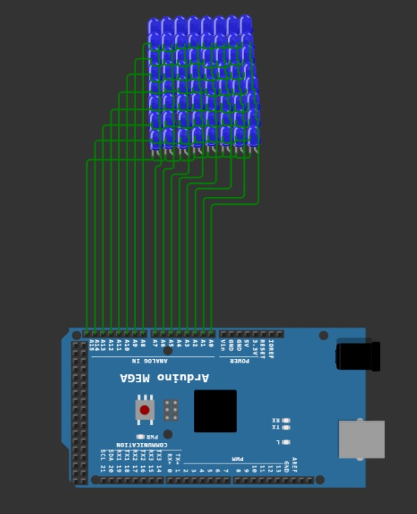
02 Display Left most Top LED :-  void setup() {  volatile char *dirf, *dirk, *outf, *outk;  volatile long a;  char i, count=0;  dirf=0x30; *dirf=0xff;  dirk=0x107; *dirk=0xff;  outf=0x31; outk=0x108;  *outf=128;  *outk=~1;  }  void loop() {} | 03 Display Right most bottom LED :-  void setup() {  volatile char *dirf, *dirk, *outf, *outk;  volatile long a;  char i, count=0;  dirf=0x30; *dirf=0xff;  dirk=0x107; *dirk=0xff;  outf=0x31; outk=0x108;  *outf=1;  *outk=~128;  }  void loop() {}
04 Display Left most bottom LED :-  void setup() {  volatile char *dirf, *dirk, *outf, *outk;  volatile long a;  char i, count=0;  dirf=0x30; *dirf=0xff;  dirk=0x107; *dirk=0xff;  outf=0x31; outk=0x108;  *outf=128;  *outk=~128;  }  void loop() {} | 05 Display Topmost Row all LEDs :-  void setup() {  volatile char *dirf, *dirk, *outf, *outk;  volatile long a;  char i, count=0;  dirf=0x30; *dirf=0xff;  dirk=0x107; *dirk=0xff;  outf=0x31; outk=0x108;  *outf=0xff;  *outk=~1;  }  void loop() {}
06 Display Bottom most Row all LEDs :-  void setup() {  volatile char *dirf, *dirk, *outf, *outk;  volatile long a;  char i, count=0;  dirf=0x30; *dirf=0xff;  dirk=0x107; *dirk=0xff;  outf=0x31; outk=0x108;  *outf=0xff;  *outk=~128;  }  void loop() {} | 
07 Display Left most Column all LEDs :-  void setup() {  volatile char *dirf, *dirk, *outf, *outk;  volatile long a;  char i, count=0;  dirf=0x30; *dirf=0xff;  dirk=0x107; *dirk=0xff;  outf=0x31; outk=0x108;  *outf=128;  *outk=0;  }  void loop() {} | 08 Display Right most Column all LEDs :-  void setup() {  volatile char *dirf, *dirk, *outf, *outk;  volatile long a;  char i, count=0;  dirf=0x30; *dirf=0xff;  dirk=0x107; *dirk=0xff;  outf=0x31; outk=0x108;  *outf=1;  *outk=0;  }  void loop() {}
09 Display diagonal LEDs connecting Left top LED to Right bottom LED :-  void setup() {  volatile char *dirf, *dirk, *outf, *outk, row, col;  dirf=0x30; *dirf=0xff; outf=0x31;  dirk=0x107; *dirk=0xff; outk=0x108;  while(1){  for(row=0; row<9; row++)  for(col=0; col<9; col++)  if(row==col){  *outf= 1 << row; *outk= ~( 128 >> col);  *outf=0; *outk=0xff;  } }  }  void loop() {} | 10 Display diagonal LEDs connecting Right top LED to Left bottom LED :-  void setup() {  volatile char *dirf, *dirk, *outf, *outk, row, col;  dirf=0x30; *dirf=0xff; outf=0x31;  dirk=0x107; *dirk=0xff; outk=0x108;  while(1){  for(row=0; row<9; row++)  for(col=0; col<9; col++)  if(row==col){  *outf= 1 << row; *outk= ~( 1 << col);  *outf=0; *outk=0xff;  } }  }  void loop() {}
ESP – Dot-matrix – Problems Set – 2
01 Display Character A :-  void setup() {  volatile char i, *dirf, *dirk, *outf, *outk;  dirf=0x30; *dirf=0xff; outf=0x31;  dirk=0x107; *dirk=0xff; outk=0x108;  volatile char num[] =  {0b00000000,  0b00011000,  0b00100100,  0b01111110,  0b10000001,  0b00000000,  0b00000000,  0b00000000};  while(1){  for(i=0; i<8; i++){  *outk= ~(1 << i); *outf = num[i];  *outk=0xff; *outf=0;  }  }  }  void loop() {} | 
02 Display Character B :-  void setup() {  volatile char i, *dirf, *dirk, *outf, *outk;  dirf=0x30; *dirf=0xff; outf=0x31;  dirk=0x107; *dirk=0xff; outk=0x108;  volatile char num[] =  {0b11111100,  0b10000010,  0b10000010,  0b11111100,  0b10000010,  0b10000010,  0b11111100,  0b00000000};  while(1){  for(i=0; i<8; i++){  *outk= ~(1 << i); *outf = num[i];  *outk=0xff; *outf=0;  }  }  }  void loop() {} | 03 Display Number 1 :-  void setup() {  volatile char i, *dirf, *dirk, *outf, *outk;  dirf=0x30; *dirf=0xff; outf=0x31;  dirk=0x107; *dirk=0xff; outk=0x108;  volatile char num[] =  {0b00011000,  0b00111000,  0b00011000,  0b00011000,  0b00011000,  0b00011000,  0b00011000,  0b00111100};  while(1){  for(i=0; i<8; i++){  *outk= ~(1 << i); *outf = num[i];  *outk=0xff; *outf=0;  }  }  }  void loop() {}
04 Display Number 2 :-  void setup() {  volatile char i, *dirf, *dirk, *outf, *outk;  dirf=0x30; *dirf=0xff; outf=0x31;  dirk=0x107; *dirk=0xff; outk=0x108;  volatile char num[] =  {0b00111110,  0b01111110,  0b01100110,  0b00001110,  0b00011100,  0b00111000,  0b01111111,  0b01111111};  while(1){  for(i=0; i<8; i++){  *outk= ~(1 << i); *outf = num[i];  *outk=0xff; *outf=0;  }  }  }  void loop() {} | 05 Display Character a :-  void setup() {  volatile char i, *dirf, *dirk, *outf, *outk;  dirf=0x30; *dirf=0xff; outf=0x31;  dirk=0x107; *dirk=0xff; outk=0x108;  volatile char num[] =  {0b00011000,  0b00100100,  0b00000100,  0b00011100,  0b00100100,  0b00100100,  0b00011010,  0b00000000};  while(1){  for(i=0; i<8; i++){  *outk= ~(1 << i); *outf = num[i];  *outk=0xff; *outf=0;  }  }  }  void loop() {}
06 Display Character q :-  void setup() {  volatile char i, *dirf, *dirk, *outf, *outk;  dirf=0x30; *dirf=0xff; outf=0x31;  dirk=0x107; *dirk=0xff; outk=0x108;  volatile char num[] =  {0b00111111,  0b01111111,  0b01100011,  0b01111111,  0b00111111,  0b00000011,  0b00000011,  0b00000011};  while(1){  for(i=0; i<8; i++){  *outk= ~(1 << i); *outf = num[i];  *outk=0xff; *outf=0;  }  }  }  void loop() {} | 07 Display Symbol $ :-  void setup() {  volatile char i, *dirf, *dirk, *outf, *outk;  dirf=0x30; *dirf=0xff; outf=0x31;  dirk=0x107; *dirk=0xff; outk=0x108;  volatile char num[] =  {0b00010000,  0b00111000,  0b01010100,  0b01010000,  0b00111000,  0b00010100,  0b01010100,  0b00111000};  while(1){  for(i=0; i<8; i++){  *outk= ~(1 << i); *outf = num[i];  *outk=0xff; *outf=0;  }  }  }  void loop() {}
08 Display Symbol # :-  void setup() {  volatile char i, *dirf, *dirk, *outf, *outk;  dirf=0x30; *dirf=0xff; outf=0x31;  dirk=0x107; *dirk=0xff; outk=0x108;  volatile char num[] =  {0b00000000,  0b00010100,  0b01111110,  0b00101000,  0b11111100,  0b01010000,  0b00000000,  0b00000000};  while(1){  for(i=0; i<8; i++){  *outk= ~(1 << i); *outf = num[i];  *outk=0xff; *outf=0;  }  }  }  void loop() {} | 
09 Display Symbol α :-  void setup() {  volatile char i, *dirf, *dirk, *outf, *outk;  dirf=0x30; *dirf=0xff; outf=0x31;  dirk=0x107; *dirk=0xff; outk=0x108;  volatile char num[] =  {0b00000000,  0b00000000,  0b00011010,  0b00100100,  0b00100100,  0b00011010,  0b00000000,  0b00000000};  while(1){  for(i=0; i<8; i++){  *outk= ~(1 << i); *outf = num[i];  *outk=0xff; *outf=0;  }  }  }  void loop() {} | 10 Display Symbol Ω :-  void setup() {  volatile char i, *dirf, *dirk, *outf, *outk;  dirf=0x30; *dirf=0xff; outf=0x31;  dirk=0x107; *dirk=0xff; outk=0x108;  volatile char num[] =  {0b00000000,  0b00000000,  0b00111000,  0b01000100,  0b01000100,  0b00101000,  0b11101110,  0b00000000};  while(1){  for(i=0; i<8; i++){  *outk= ~(1 << i); *outf = num[i];  *outk=0xff; *outf=0;  }  }  }  void loop() {}
01 Display Characters A to E one by one in one second Interval :-  void setup(){  volatile char *dirf, *dirk, *outf, *outk;  volatile long a;  char i, count=0;  dirf=0x30; *dirf=0xff; outf=0x31;  dirk=0x107; *dirk=0xff; outk=0x108;  volatile char abcde[][8] = {  {0b00000000, 0b00011000, 0b00100100,  0b01111110, 0b10000001, 0b00000000,  0b00000000, 0b00000000}, // A  {0b01111000, 0b01000100, 0b01000100,  0b01111000, 0b01000100, 0b01000100,  0b01111000, 0b00000000}, // B  {0b00000000, 0b00111000, 0b01000100,  0b01000000, 0b01000000, 0b01000100,  0b00111000, 0b00000000}, // C  {0b00000000, 0b01111000, 0b01000100,  0b01000100, 0b01000100, 0b01000100,  0b01111000, 0b00000000}, // D  {0b00000000, 0b01111100, 0b01000000,  0b01111100, 0b01000000, 0b01111100,  0b00000000, 0b00000000}}; // E  while(1){  for(a=0; a<20000; a++){  for(i=0; i<8; i++)  {  *outk= ~(1 << i);  *outf = ecen[count][i];  *outk=0xff;  *outf=0;  }  }  for(a=0; a<45000; a++);  count++;  if(count==5) count=0;  }  }  void loop() {} | 02 Display Characters a to e one by one in one second Interval :-  void setup(){  volatile char *dirf, *dirk, *outf, *outk;  volatile long a;  char i, count=0;  dirf=0x30; *dirf=0xff; outf=0x31;  dirk=0x107; *dirk=0xff; outk=0x108;  volatile char ecen[][8] = {  {0b00011000, 0b00100100, 0b00000100,  0b00011100, 0b00100100, 0b00100100,  0b00011010, 0b00000000}, // a  {0b00100000, 0b00100000, 0b00100000,  0b00111000, 0b00100100, 0b00100100,  0b00011000, 0b00000000}, // b  {0b00000000, 0b00011000, 0b00100100,  0b00100000, 0b00100000, 0b00100100,  0b00011000, 0b00000000}, // c  {0b00000100, 0b00000100, 0b00000100,  0b00011100, 0b00100100, 0b00100100,  0b00011000, 0b00000000}, //d  {0b00000000, 0b00011000, 0b00100100,  0b00111100, 0b00100000, 0b00011000,  0b00000000, 0b00000000}}; //e  while(1){  for(a=0; a<20000; a++){  for(i=0; i<8; i++)  {  *outk= ~(1 << i);  *outf = ecen[count][i];  *outk=0xff;  *outf=0;  }  }  for(a=0; a<45000; a++);  count++;  if(count==5) count=0;  }  }  void loop() {}
ESP – Dot-matrix – Problems Set – 3
03 Display Numbers 0 to 4 one by one in one second Interval :-  void setup(){  volatile char *dirf, *dirk, *outf, *outk;  volatile long a;  char i, count=0;  dirf=0x30; *dirf=0xff; outf=0x31;  dirk=0x107; *dirk=0xff; outk=0x108;  volatile char ecen[][8] = {  {0b00010000, 0b00110000, 0b00010000,  0b00010000, 0b00010000, 0b00010000,  0b00010000, 0b00111000}, // 1  {0b00111100, 0b01000010, 0b01000100,  0b00001000, 0b00010000, 0b00100000,  0b01111110, 0b00000000}, // 2  {0b00111110, 0b00000100, 0b00001000,  0b00011100, 0b00000010, 0b01000010,  0b00111100, 0b00000000}, // 3  {0b00000000, 0b00010100, 0b00100100,  0b01000100, 0b01111110, 0b00000100,  0b00000100, 0b00000000}, // 4  {0b00000000, 0b00111100, 0b00100000,  0b00111000, 0b00000100, 0b00100100,  0b00011000, 0b00000000}};  while(1){  for(a=0; a<20000; a++){  for(i=0; i<8; i++)  {  *outk= ~(1 << i);  *outf = ecen[count][i];  *outk=0xff;  *outf=0;  }  }  for(a=0; a<45000; a++);  count++;  if(count==5) count=0;  }  }  void loop() {} | 04 Display Welcome string characters one by one in one second Interval :-  void setup(){  volatile char *dirf, *dirk, *outf, *outk;  volatile long a;  char i, count=0;  dirf=0x30; *dirf=0xff; outf=0x31;  dirk=0x107; *dirk=0xff; outk=0x108;  volatile char ecen[][8] = {  {0b11000011, 0b11000011, 0b11000011,  0b11000011, 0b11011011, 0b11111111,  0b11100111, 0b11000011}, // W  {0b00000000, 0b00000000, 0b00000000,  0b00111100, 0b01100110, 0b01111110,  0b01100000, 0b00111100}, //e  {0b00011000, 0b00011000, 0b00011000,  0b00011000, 0b00011000, 0b00011000,  0b00011000, 0b00001100}, // l  {0b00000000, 0b00000000, 0b00000000,  0b00111100, 0b01101100, 0b01100000,  0b01100000, 0b00111100}, //c  {0b00000000, 0b00000000, 0b00000000,  0b00111100, 0b01100110, 0b01100110,  0b01100110, 0b00111100}, //o  {0b00000000, 0b00000000, 0b00000000,  0b01110110, 0b11011011, 0b11011011,  0b11011011, 0b11011011}, // m  {0b00000000, 0b00000000, 0b00000000,  0b00111100, 0b01100110, 0b01111110,  0b01100000, 0b00111100}}; //e  while(1){  for(a=0; a<20000; a++){  for(i=0; i<8; i++)  {  *outk= ~(1 << i);  *outf = ecen[count][i];  *outk=0xff;  *outf=0;  } }  for(a=0; a<45000; a++);  count++;  if(count==7) count=0;  } }  void loop() {}
05 Display revolving text “Welcome” Right to Left :-  void setup(){  volatile char *dirf, *dirk, *outf, *outk;  volatile long a, b;  char i, j, count=0;  dirf=0x30; *dirf=0xff; outf=0x31;  dirk=0x107; *dirk=0xff; outk=0x108;  volatile char arr[] = {  0, 0, 0, 0, 0, 0, 0, 0,  0b11111111, 0b11111111, 0b01100000,  0b00110000, 0b00110000, 0b01100000,  0b11111111, 0b11111111, // W  0b00000000, 0b01110000, 0b11111000,  0b10101000, 0b10101000, 0b10111000,  0b00110000, 0b00000000, // e  //0b00000000, 0b00000000, 0b00000000,  0b01111111, 0b11111111, 0b10000000,  //0b00000000, 0b00000000, // l  0b00000000, 0b01110000, 0b11111000,  0b10001000, 0b10011000, 0b10011000,  //0b00000000, 0b00000000, // c  0b00000000, 0b01110000, 0b11111000,  0b10001000, 0b10001000, 0b11111000,  0b01110000, 0b00000000, // o  0b11110000, 0b11111000, 0b00001000,  0b11111000, 0b11110000, 0b00001000,  0b11111000, 0b11110000, // m  0b00000000, 0b01110000, 0b11111000,  0b10101000, 0b10101000, 0b10111000,  0b00110000, 0b00000000, // e  0, 0, 0, 0, 0, 0, 0, 0,  };  while(1){  for(i=0; i<57; i++){  for(a=0; a<8000; a++){  for(j=0; j<8; j++){  *outf= 128 >> j;  *outk= ~(arr[i+j]);  *outk=0xff;  *outf=0;  }  }  for(b=0; b<32000; b++);  }  }  }  void loop() {} | 06 Display revolving text “Welcome” Left to Right :-  void setup(){  volatile char *dirf, *dirk, *outf, *outk;  volatile long a, b;  char i, j, count=0;  dirf=0x30; *dirf=0xff; outf=0x31;  dirk=0x107; *dirk=0xff; outk=0x108;  volatile char arr[] = {  0, 0, 0, 0, 0, 0, 0, 0,  0b00000000, 0b01110000, 0b11111000,  0b10101000, 0b10101000, 0b10111000,  0b00110000, 0b00000000, // e  0b11110000, 0b11111000, 0b00001000,  0b11111000, 0b11110000, 0b00001000,  0b11111000, 0b11110000, // m  0b00000000, 0b01110000, 0b11111000,  0b10001000, 0b10001000, 0b11111000,  0b01110000,// 0b00000000, // o  0b00000000, 0b01110000, 0b11111000,  0b10001000, 0b10011000, 0b10011000,  0b00000000, //0b00000000, // c  //0b00000000, 0b00000000, 0b00000000,  0b01111111, 0b11111111, 0b10000000,  //0b00000000, 0b00000000, // l  0b00000000, 0b01110000, 0b11111000,  0b10101000, 0b10101000, 0b10111000,  0b00110000, 0b00000000, // e  0b11111111, 0b11111111, 0b01100000,  0b00110000, 0b00110000, 0b01100000,  0b11111111, 0b11111111, // W  0, 0, 0, 0, 0, 0, 0, 0,  };  while(1){  for(i=56; i>=0; i--){  for(a=0; a<8000; a++){  for(j=0; j<8; j++){  *outf= 128 >> j;  *outk= ~(arr[i+j]);  *outk=0xff;  *outf=0;  }  }  for(b=0; b<32000; b++);  }  }  }  void loop() {}

07 Display revolving text “Welcome” Top to Bottom :-  void setup(){  volatile char *dirf, *dirk, *outf, *outk;  volatile long a, b;  char i, j, count=0;  dirf=0x30; *dirf=0xff; outf=0x31;  dirk=0x107; *dirk=0xff; outk=0x108;  volatile char arr[] = {  0, 0, 0, 0, 0, 0, 0, 0,  0b11000011, 0b11100111, 0b11111111,  0b11011011, 0b11000011, 0b11000011,  0b11000011, 0b11000011, 0, // W  0b00111100, 0b01100000, 0b01111110,  0b01100110, 0b00111100, 0b00000000,  // 0b00000000, 0b00000000, //e  0b00001100, 0b00011000, 0b00011000,  0b00011000, 0b00011000, 0b00011000,  0b00011000, 0b00011000, 0, // l  0b00111100, 0b01100000, 0b01100000,  0b01101100, 0b00111100, 0b00000000,  // 0b00000000, 0b00000000, //c  0b00111100, 0b01100110, 0b01100110,  0b01100110, 0b00111100, 0b00000000,  // 0b00000000, 0b00000000, //o  0b11011011, 0b11011011, 0b11011011,  0b11011011, 0b01110110, 0b00000000,  // 0b00000000, 0b00000000, // m  0b00111100, 0b01100000, 0b01111110,  0b01100110, 0b00111100, 0b00000000,  //0b00000000, 0b00000000, //e  0, 0, 0, 0, 0, 0, 0, 0,  };  while(1){  for(i=0; i<58; i++){  for(a=0; a<8000; a++){  for(j=0; j<8; j++){  *outk= ~(128 >> j);  *outf= arr[i+j];  *outk=0xff;  *outf=0;  }  }  for(b=0; b<32000; b++);  }  }  }  void loop() {} | 08 Display revolving text “Welcome” Bottom to Top :-  void setup(){  volatile char *dirf, *dirk, *outf, *outk;  volatile long a, b;  char i, j, count=0;  dirf=0x30; *dirf=0xff; outf=0x31;  dirk=0x107; *dirk=0xff; outk=0x108;  volatile char arr[] = {  0, 0, 0, 0, 0, 0, 0, 0,  0b11000011, 0b11000011, 0b11000011,  0b11000011, 0b11011011, 0b11111111,  0b11100111, 0b11000011, // W  0b00000000, // 0b00000000, 0b00000000,  0b00111100, 0b01100110, 0b01111110,  0b01100000, 0b00111100, 0, //e  0b00011000, 0b00011000, 0b00011000,  0b00011000, 0b00011000, 0b00011000,  0b00011000, 0b00001100, // l  0b00000000, // 0b00000000, 0b00000000,  0b00111100, 0b01101100, 0b01100000,  0b01100000, 0b00111100, //c  0b00000000, // 0b00000000, 0b00000000,  0b00111100, 0b01100110, 0b01100110,  0b01100110, 0b00111100, //o  0b00000000, // 0b00000000, 0b00000000,  0b01110110, 0b11011011, 0b11011011,  0b11011011, 0b11011011, // m  0b00000000, // 0b00000000, 0b00000000,  0b00111100, 0b01100110, 0b01111110,  0b01100000, 0b00111100, //e  0, 0, 0, 0, 0, 0, 0, 0  };  while(1){  for(i=0; i<57; i++){  for(a=0; a<8000; a++){  for(j=0; j<8; j++){  *outk= ~(1 << j);  *outf= arr[i+j];  *outk=0xff;  *outf=0;  }  }  for(b=0; b<32000; b++);  }  }  }  void loop() {}
  09 Display “Welcome” by odd position entering from Left and Even Position entering from Right :-  void setup(){  volatile char *dirf, *dirk, *outf, *outk;  volatile long a, b;  char i, j, count=0;  dirf=0x30; *dirf=0xff; outf=0x31;  dirk=0x107; *dirk=0xff; outk=0x108;  volatile char arr[][24] = {  {0, 0, 0, 0, 0, 0, 0, 0,  0b11111111, 0b11111111, 0b01100000,  0b00110000, 0b00110000, 0b01100000,  0b11111111, 0b11111111,  0, 0, 0, 0, 0, 0, 0, 0}, // W  {0, 0, 0, 0, 0, 0, 0, 0,  0b00000000, 0b01110000, 0b11111000,  0b10101000, 0b10101000, 0b10111000,  0b00110000, 0b00000000,  0, 0, 0, 0, 0, 0, 0, 0}, // e  {0, 0, 0, 0, 0, 0, 0, 0,  0b00000000, 0b00000000, 0b00000000,  0b01111111, 0b11111111, 0b10000000,  0b00000000, 0b00000000,  0, 0, 0, 0, 0, 0, 0, 0}, // l  {0, 0, 0, 0, 0, 0, 0, 0,  0b00000000, 0b01110000, 0b11111000,  0b10001000, 0b10011000, 0b10011000,  0b00000000, 0b00000000,  0, 0, 0, 0, 0, 0, 0, 0}, // c  {0, 0, 0, 0, 0, 0, 0, 0,  0b00000000, 0b01110000, 0b11111000,  0b10001000, 0b10001000, 0b11111000,  0b01110000, 0b00000000,  0, 0, 0, 0, 0, 0, 0, 0}, // o  {0, 0, 0, 0, 0, 0, 0, 0,  0b11110000, 0b11111000, 0b00001000,  0b11111000, 0b11110000, 0b00001000,  0b11111000, 0b11110000,  0, 0, 0, 0, 0, 0, 0, 0}, // m  {0, 0, 0, 0, 0, 0, 0, 0,  0b00000000, 0b01110000, 0b11111000,  0b10101000, 0b10101000, 0b10111000,  0b00110000, 0b00000000,  0, 0, 0, 0, 0, 0, 0, 0}}; // e  while(1){  loop:  for(i=16; i>=0; i--){  for(a=0; a<8000; a++){  for(j=0; j<8; j++){  *outf= 128 >> j;  *outk= ~(arr[count][i+j]);  *outk=0xff;  *outf=0;  }  }  for(b=0; b<32000; b++);  }  count++;  if(count>6){count=0; goto loop;}  for(i=0; i<17; i++){  for(a=0; a<8000; a++){  for(j=0; j<8; j++){  *outf= 128 >> j;  *outk= ~(arr[count][i+j]);  *outk=0xff;  *outf=0;  } }  for(b=0; b<32000; b++);  }  count++;  } }  void loop() {} |   10 Display “Welcome” by odd position entering from Top and Even Position entering from Bottom :-  void setup(){  volatile char *dirf, *dirk, *outf, *outk;  volatile long a, b;  char i, j, count=0;  dirf=0x30; *dirf=0xff; outf=0x31;  dirk=0x107; *dirk=0xff; outk=0x108;  volatile char arr[][24] = {  {0, 0, 0, 0, 0, 0, 0, 0,  0b11000011, 0b11100111, 0b11111111,  0b11011011, 0b11000011, 0b11000011,  0b11000011, 0b11000011, // W  0, 0, 0, 0, 0, 0, 0, 0},  {0, 0, 0, 0, 0, 0, 0, 0,  0b00111100, 0b01100000, 0b01111110,  0b01100110, 0b00111100, 0b00000000,  0b00000000, 0b00000000, //e  0, 0, 0, 0, 0, 0, 0, 0},  {0, 0, 0, 0, 0, 0, 0, 0,  0b00001100, 0b00011000, 0b00011000,  0b00011000, 0b00011000, 0b00011000,  0b00011000, 0b00011000, // l  0, 0, 0, 0, 0, 0, 0, 0},  {0, 0, 0, 0, 0, 0, 0, 0,  0b00111100, 0b01100000, 0b01100000,  0b01101100, 0b00111100, 0b00000000,  0b00000000, 0b00000000, //c  0, 0, 0, 0, 0, 0, 0, 0},  {0, 0, 0, 0, 0, 0, 0, 0,  0b00111100, 0b01100110, 0b01100110,  0b01100110, 0b00111100, 0b00000000,  0b00000000, 0b00000000, //o  0, 0, 0, 0, 0, 0, 0, 0},  {0, 0, 0, 0, 0, 0, 0, 0,  0b11011011, 0b11011011, 0b11011011,  0b11011011, 0b01110110, 0b00000000,  0b00000000, 0b00000000, // m  0, 0, 0, 0, 0, 0, 0, 0},  {0, 0, 0, 0, 0, 0, 0, 0,  0b00111100, 0b01100000, 0b01111110,  0b01100110, 0b00111100, 0b00000000,  0b00000000, 0b00000000, //e  0, 0, 0, 0, 0, 0, 0, 0}};  while(1){  loop:  for(i=0; i<17; i++){  for(a=0; a<8000; a++){  for(j=0; j<8; j++){  *outk= ~(128 >> j);  *outf= arr[count][i+j];  *outk=0xff;  *outf=0;  }  }  for(b=0; b<32000; b++);  }  count++;  if(count>6){count=0; goto loop;}  for(i=16; i>=0; i--){  for(a=0; a<8000; a++){  for(j=0; j<8; j++){  *outk= ~(128 >> j);  *outf= arr[count][i+j];  *outk=0xff;  *outf=0;  }  }  for(b=0; b<32000; b++);  }  count++;  } }  void loop() {}

